UCINET Quick Start Guide

This guide provides a quick introduction to UCINET. It assumes that the software has been installed with the data in the folder C:\Users\<username>\Documents\UCINET Data and this has been left as the default directory.

When UCINET is started the following window appears.

Submenu buttons

Launch Excel

Copy dataset to clipboard

Display dataset

Change default directory button

Current default directory

Exit button

Matrix Editor

DL editor

Text editor (notepad)

Command Line Interface

Run Netdraw and quick start Netdraw (QD)

The submenu buttons give access to all of the routines in UCINET and these are grouped into **File, Data, Transform, Tools, Network, Visualize, Options and Help.** Note that the buttons located below these are simply fast ways of calling routines in the submenus. The default directory given at the bottom is where UCINET picks up any data and stores any files (unless otherwise specified) this directory can be changed by clicking on the button to the right.

The launch Excel button converts a UCINET dataset to Excel and launches Excel. The copy to clipboard converts a UCINET dataset to a text file and copies it onto the clipboard.

Running a routine

To run a UCINET routine we usually need to specify a UCINET dataset and give some parameters. Where possible UCINET selects some default parameters which the user can change if required. Note that UCINET comes with a number of standard datasets and these will be located in the default directory. When a routine has been run there is some textual output which appears on the screen and usually a UCINET datafile containing the results that again will be stored in the default directory.

We shall run the degree centrality routine to calculate the centralities of all the actors in a standard UCINET dataset called TARO. First we highlight Network|Centrality|Degree and then left click.

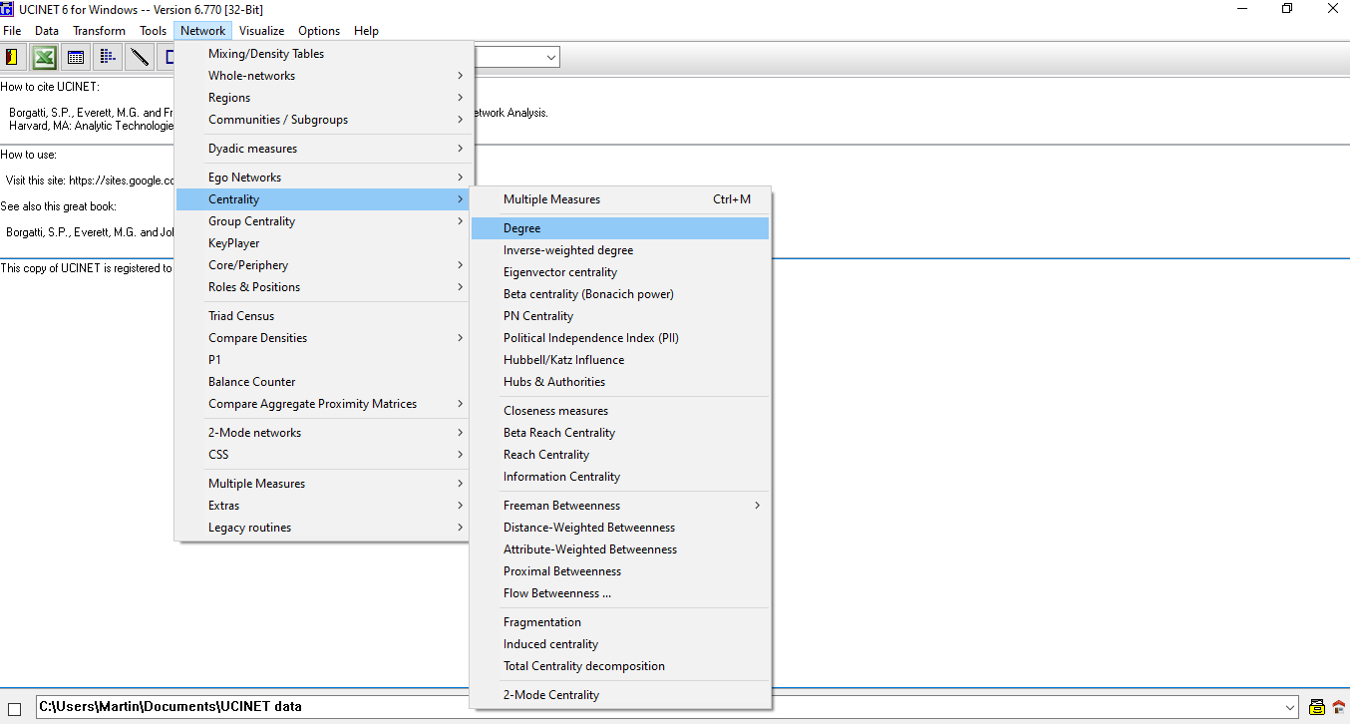

Click to open a pick file box

This will bring up a box as follows

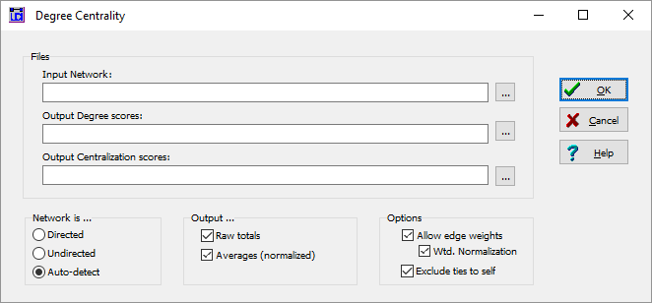

Defaults, options and parameters can be changed by clicking.

Click to run the routine

Click to access help associated with this routine

Click to cancel

Name of UCINET datafiles created by this routine. Can be changed by typing over

If you click on the help button then a help screen will open which looks like this. The help file gives a detailed description of the routine, explains the parameters and describes the output that will appear in the log file and on the screen.

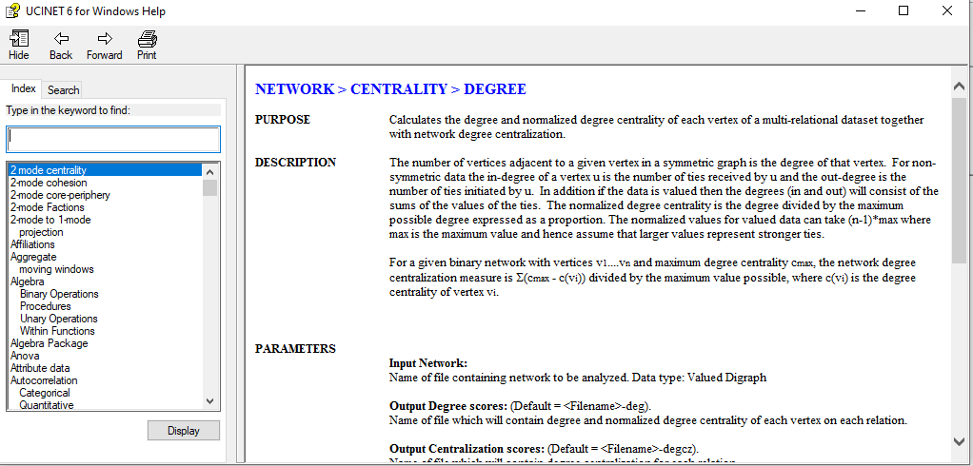

Close the help file and either by clicking on the pickfile button or by typing the name select the TARO data for analysis as follows.

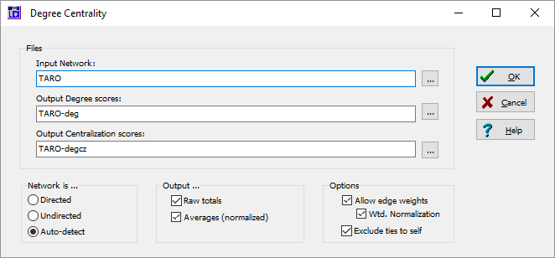

Now click OK to run the routine to obtain the following.

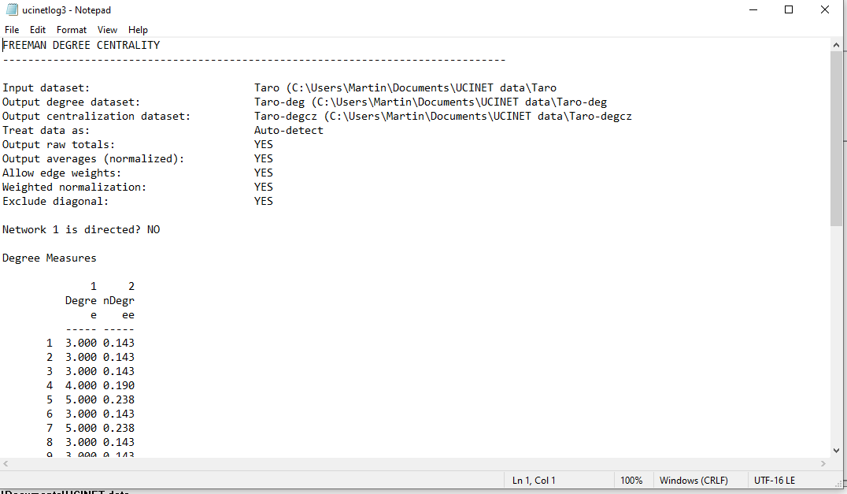

This is a text file giving the results of the routine. Note you can scroll down to see more of the file. This file can be saved or copied and pasted into a word processing package. When UCINET is closed this file will be deleted. Close this file.

Note when the program was run we also created two new UCINET files one called TARO-deg the other called TARO-degcz. We can look at the new UCINET file using the Display dataset button. This is the D button that appears just below the Tools submenu (see the first diagram). Clicking on the D goes straight to the open file menu and bypasses some of the display options that are available if you used Data|Display. Click on display and select TARO-deg. You should get the following

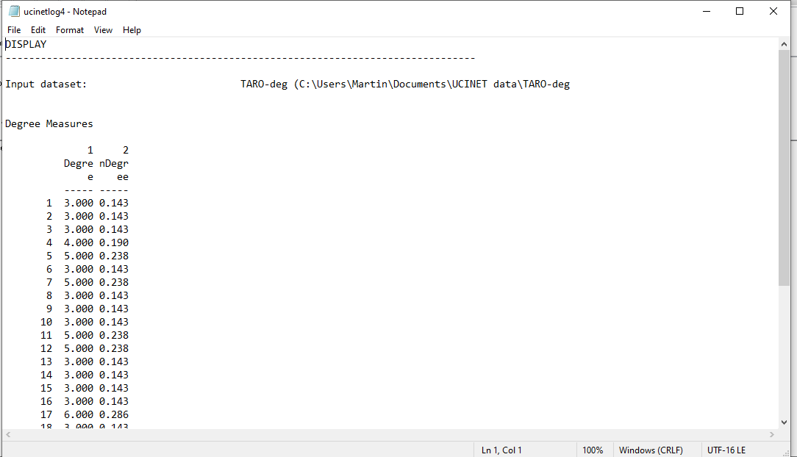

Note that this file has all the measures of centrality but does not have the descriptive statistics produced in the log file.

Using the Matrix editor

The Matrix editor can be used to amend or view data. It is also useful for transferring UCINET data (such as centrality scores) to Microsoft Excel or SPSS. Note that although the matrix editor can be used for entering data the dl editor provides a more sophisticated and flexible way of entering data and this is covered later in this introductory guide. If you click the Matrix Editor button or under data click on Matrix Editor you will open up the Matrix Editor and obtain the following. Note we have annotated the important buttons and areas of the editor below.

Click to clear or start a new sheet

Set the network or matrix size here including more levels or s

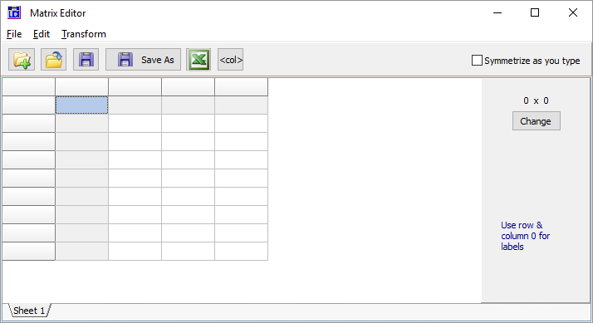

Symmetric mode copies cell values into other half

Area for data, numerical values only

Click Transform and Fill to add zeros into empty cells

Area for labels

To see what a dataset looks like in the editor click file then open and select PADGETT. This is a non-symmetric binary data set with two relations and labels. Once open it will look like this.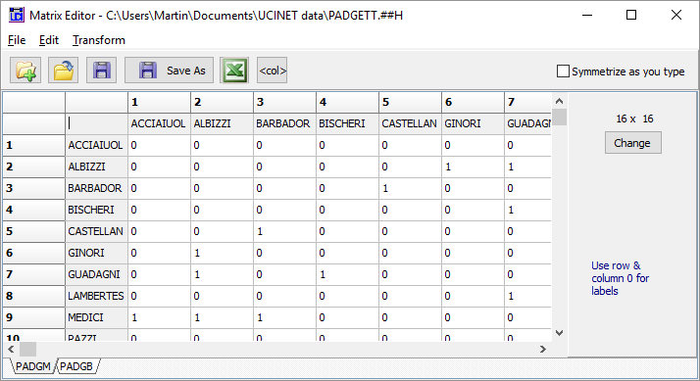

We see the two relations PADGM and PADGB in the bottom left, clicking on the tabs changes sheet and we are viewing different relations. The labels are repeated along the rows and columns and are in the shaded area. We see the data has 16 actors as shown by the dimensions box on the right. This data can be edited and saved from the spreadsheet.

Running Netdraw

Click on the Netdraw button  to launch Netdraw. This results in a new window which looks like this. We have annotated the most important buttons.

Hide or reveal labels

Change label size

Change shape of nodes

Restore nodes

Hide or reveal arrows

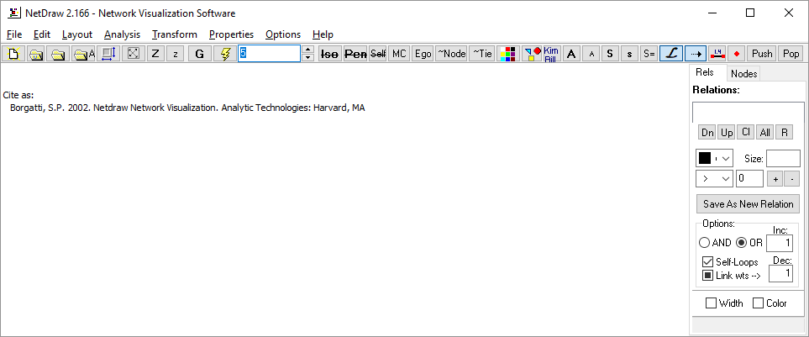

Change node size

Hide or reveal edge weights

Colour nodes

Show only main component

Remove isolates

Arrange nodes

Clear window

Load a file

To use Netdraw it is important to load in a network first. We shall load in a standard UCINET dataset collected by Dave Krackhardt. Click on the load a file button and type or select the file KrackNet

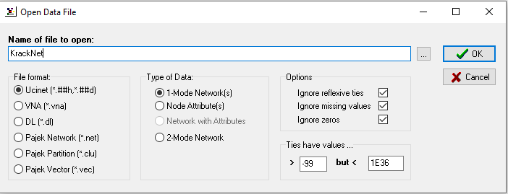

Then click OK and you should see something like this. 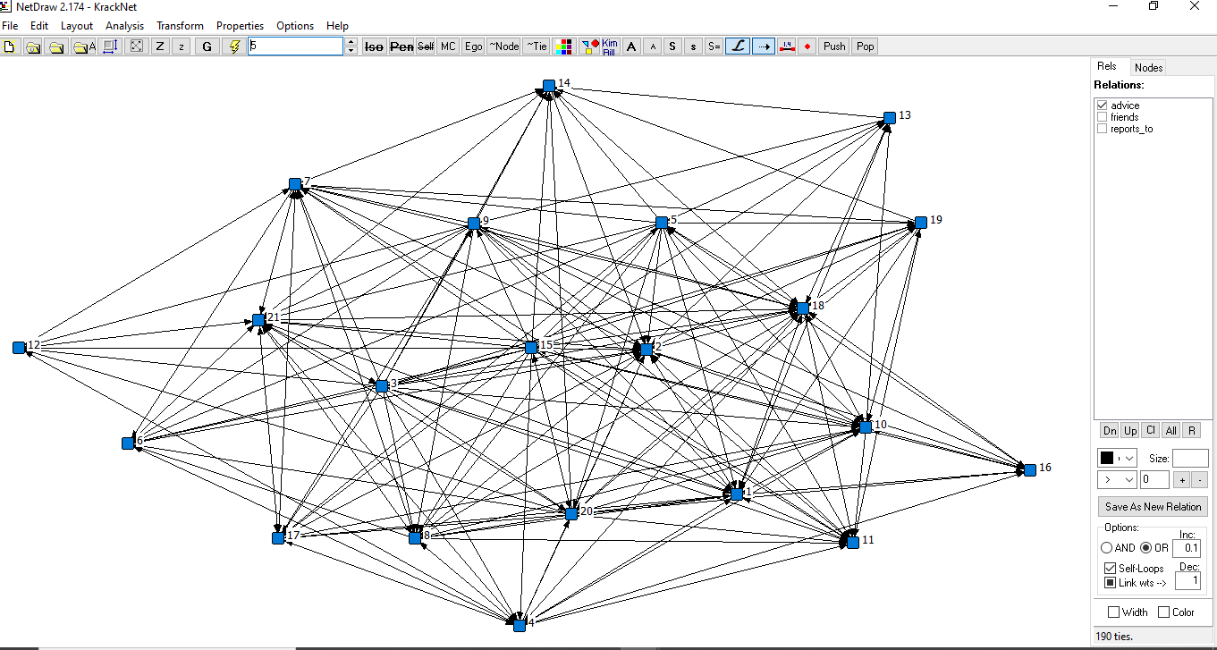

You will now see this data has three relations Advice, Friendship and Reports to. If a relation is ticked then the edges relating to it are displayed. We shall now bring in an attribute file associated with this data called Krackattr. Click on the load a file button again load the file but also click the radio button for node attributes under Type of Data so you have

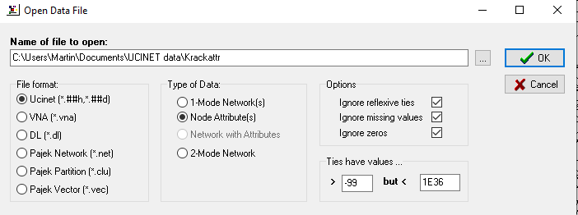

Note you can also click the button just to the right of the load button (with an A) and this will open up the same box but with the attribute button selected. Click on Transform> Node attribute editor and you will see the node attribute editor open up as follows.

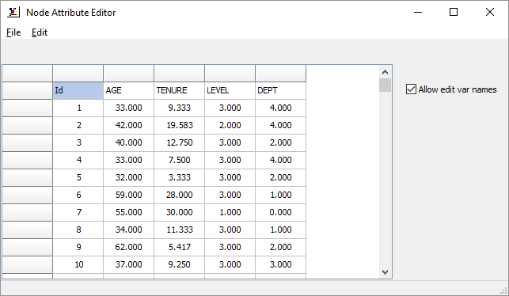

You can use this editor to change or add in new attributes.

We are going to size the nodes by age, colour them by department and shape them according to level. Close the attribute editor and click on the color node button. This will open the color box, click the select attribute button and select department as follows

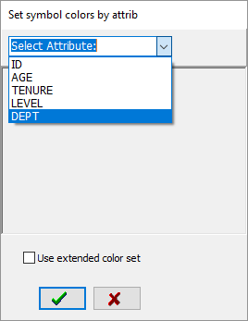

This will give 5 colours for the five departments, you can change the colours by clicking on the colour. When you are satisfied with the colours click the tick at the bottom of the box. Now click on the change shape of nodes button and go through the same process but selecting level and clicking on the tick at the bottom of the box. This will produce three shapes. To size the nodes according to age you need to select Properties>Nodes>Symbols>Size>Attribute-Based and then select Age leaving the other values as defaults. This should result in the following (but with different colors depending on what you selected).

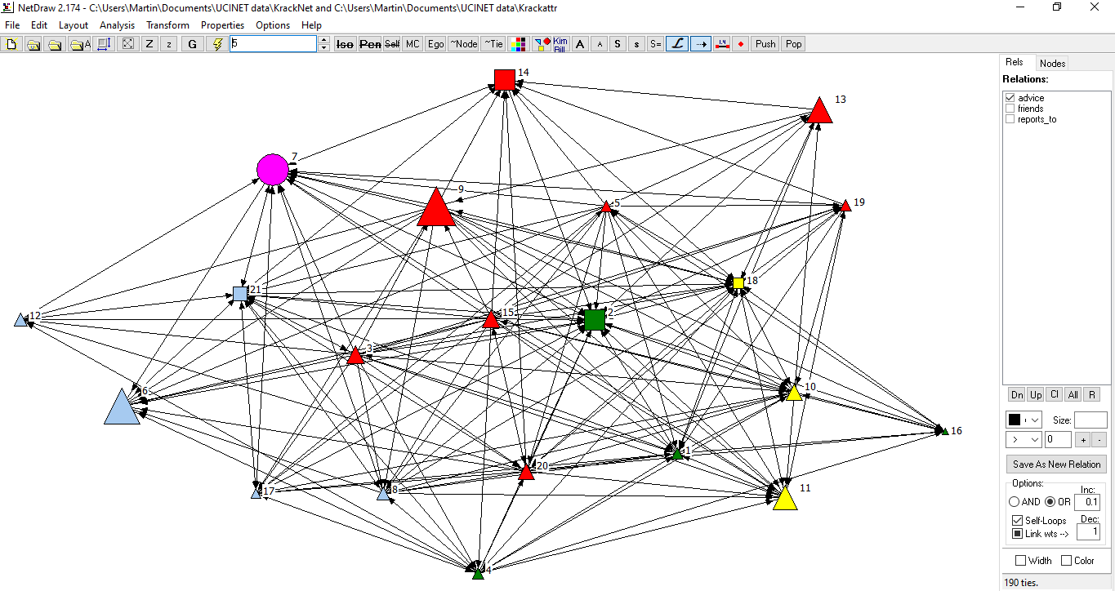

To export the diagram for use in a publication or to read into a word processing package use File>Save Diagram As>Metafile. To save the diagram as a file you can see again in Netdraw you need to use File>Save Data As>Vna.

**Using the dl editor in UCINET**

The UCINET spreadsheet editor is useful for making changes or for viewing data but is not well suited for importing larger datasets in which the data is not typically arranged in an adjacency matrix format. UCINET supports a variety of data formats that are accessed through an editor called the dl editor which is launched by pressing the button to the right of the spreadsheet editor in UCINET which looks like this



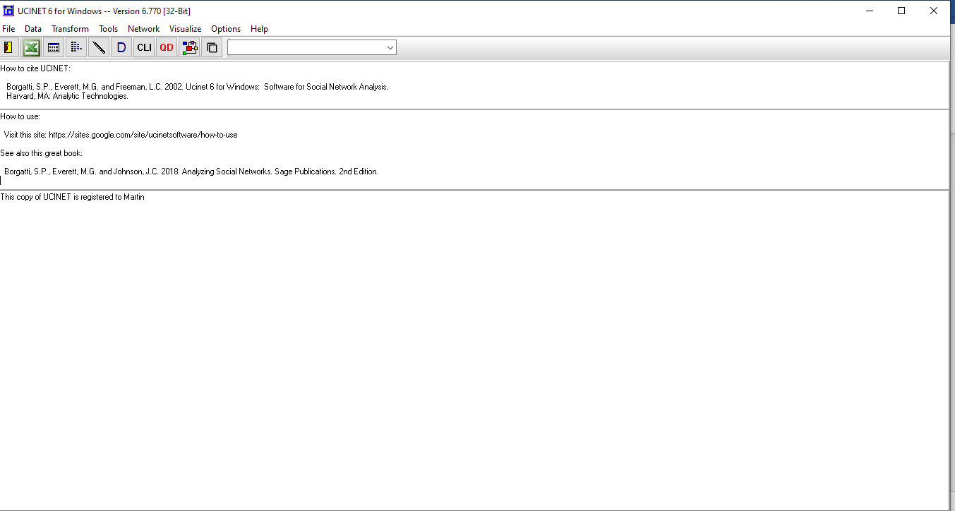

When the editor is launched you should obtain the following. 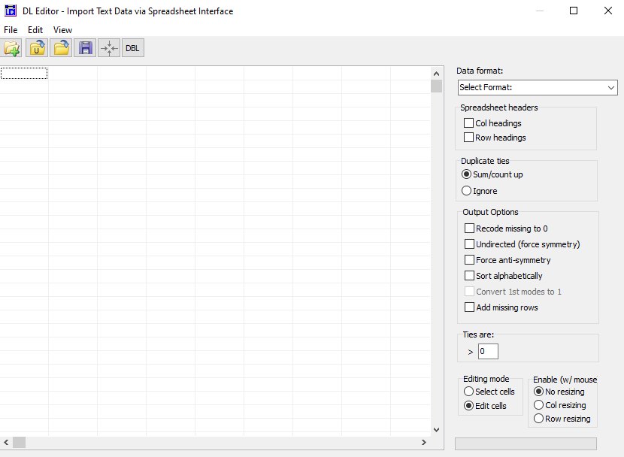

Data format selection

There are a number of data formats supported but we will just look at two. The data formats can be selected from a pull down list by clicking the arrow to the right of the data format selection box. The full matrix is the same as using the normal spreadsheet editor. Our first format is called Nodelist1 (ego alter1 alter2 ...), this format lists each node followed by the nodes it is adjacent to. The following is an example, note we have clicked the force symmetry box in the output options.

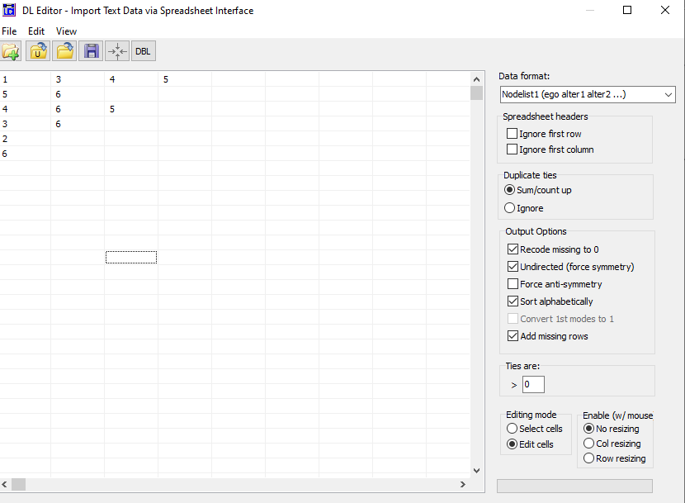

The first number in each row gives the starting node of an edge the numbers that follow in the same row are a list of end nodes. Hence the first row 1 3 4 5 states that actor 1 is connected to actors 3, 4 and 5. The second row states that actor 5 is connected to actor 6 and so on. Note that there is no order amongst the rows nor within the rows. Actor 2 has no end nodes listed and hence is an isolate. The network corresponding to this linked list is given below.

simple.emf

Note that the entries in the spreadsheet are labels and so we can use names rather than numbers. If the data is directed then the arc goes from the start node to the end node. The following is an example showing a directed network with labels.

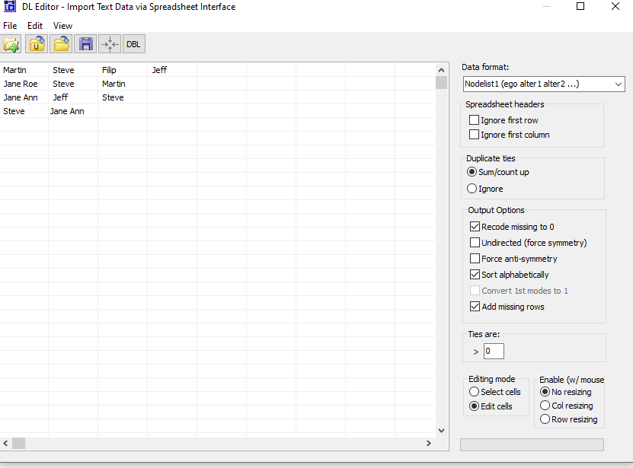

If the data is valued then we cannot use the nodelist format; an alternative is the Edgelist1 (ego alter [value]) format. This format has three entries per line and is of the form start node, end node , value. The following is an example.

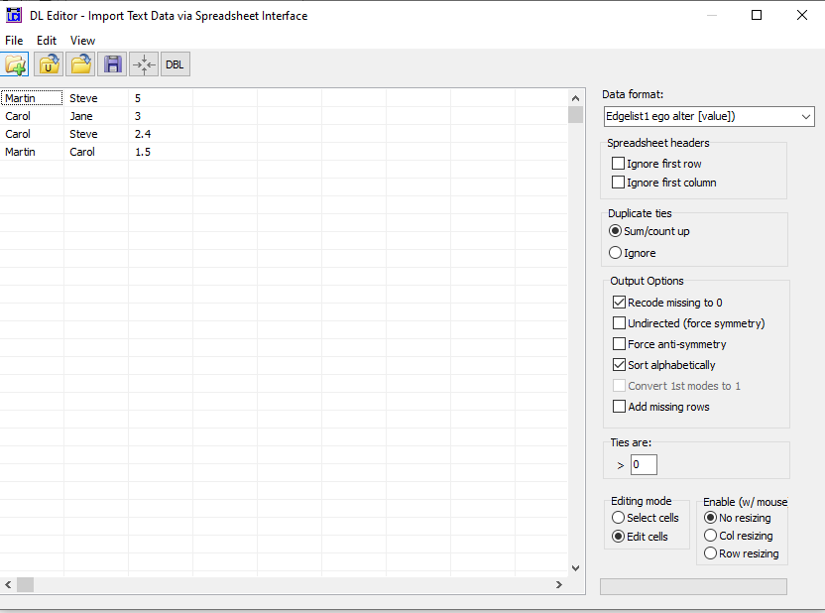

In this example we see that Martin has a connection to Steve with a value of 5. It should be noted that the data in the spreadsheet cannot be saved except as a UCINET file and hence it is a good idea to construct these in an excel spreadsheet and copy and paste or import them. Once the entry is complete the file can be saved in UCINET by clicking the File button and selecting Save UCINET dataset. To clear the spreadsheet click the  on the top left hand side.

There are many features of UCINET and Netdraw that we have not mentioned but hopefully this guide will get you started.