ANT3930 Applied Anthropology Spring 2026 Dr. Jeffrey C. Johnson
Office Hours: Monday 1:00-3:00, Thursday 2:00-3:00, Wednesday 3:00-4:00, BEBR, Ayers Building, Room 101
Email: johnsonje@ufl.edu
Class Meets: Tuesday, 11:45 AM - 1:40 PM and Thursday, 12:50 PM - 1:40 PM and , DAU 0342
Text: No text. Readings will be provided via e-mail or will be available on the website.
Overall Objective of the Class: TO GIVE STUDENTS AN UNDERSTANDING OF THE ELEMENTS OF APPLIED ANTHROPOLOGICAL WORK AND THE WORK OF ACTUAL APPLIED ANTHROPOLOGISTS.
What is anthropology? “A scholarly discipline that aims to describe in the broadest possible sense what it means to be human” (Lavenda & Schultz, 2015:5). What is applied anthropology? The Society for Applied Anthropology has stated applied anthropology is the “scientific investigation of the principles controlling the relations of human beings to one another, and the encouragement of the wide application of these principles to practical problems ” (Griffith, David, Jeffrey C. Johnson, Jeanne Simonelli, Bill Roberts, and James Wallace eds. “Mission statement”. Society for Applied Anthropology, 2008. Retrieved on 3 February 2008 from http://www.sfaa.net/).
Scope and Background: Applied anthropology is the application of anthropological theory and methods to the solution of practical problems (putting anthropology to use; Van Willigen). This class will review and analyze the work of applied anthropologists, in particular, work that has been awarded the Praxis Award by WAPA (The Washington Association of Professional Anthropologists). WAPA describes the award as:
“Since 1981, the Washington Association of Professional Anthropologists (WAPA) biennial Praxis Award has recognized outstanding achievement in translating anthropological knowledge into action as reflected in a single project or specific, longer-term endeavor. Ideal candidates are anthropologists who can demonstrate the value of anthropological knowledge, theory and methods to solve problems in government and industry (including both profit and non-profit sectors). “
Students will learn how anthropology has been applied to solve real world problems and will explore the range of occupational opportunities for anthropologists outside the academy. On a weekly basis, readings on the work from the award winning projects will be analyzed and discussed, along with work that received honorable mentions. There will also be additional supplemental readings and examples of applied projects.

Course Requirements and Grading
A (90-100), A- (87-89), B+ (84-86), B (80- 83), B- (77-79), C+ (74-77), C (70-73), C- (67-69), D+ (64-66), D
(60-63), D- (57-59), E (<57).

- Class participation (10%). Your participation grade is based on your participation in class discussions.
- Assignments (40%). Students are required to provide a brief summary of information gathered online on their selection of the winners or one of the honorable mentions in the Praxis Award document attached to the syllabus. Descriptions should be no longer the one double-spaced page.

- Mid-term Exam (20%). There will be an essay exam on materials discussed in the first half of the course.
- Final presentation (30%). The final presentation and paper will be adiscussion of how applied anthropology can address a problem of interest to you. Topics will need to be approved by me. Your paper and presentation should demonstrate your proficiency in understanding the different elements of an applied anthropological project.
For further information on UF’s Grading Policy, see: http://www.registrar.ufl.edu/catalog1011/policies/regulationgrades.html http://www.isis.ufl.edu/minusgrades.html

Policy on Late Assignments
Assignments must be complete by due date. Late assignments will lose one half-grade for each day late.

Academic Honor Code
Unless it is specifically connected to assigned collaborative work, all work should be individual. Evidence of collusion (working with someone not connected to the class or assignment), plagiarism (use of someone else’s published or unpublished words or design without acknowledgment) or multiple submissions (submitting the same paper in different courses) will lead to the Department’s and the
University’s procedures for dealing with academic dishonesty. All students are expected to honor their
commitment to the university’s honor code. See: http://www.dso.ufl.edu/sccr/honorcodes/honorcode.php Accommodation for Students with Disabilities
Students requesting classroom accommodation must first register with the Dean of Students Office. The Dean of Students Office will provide documentation to the student who must then provide this documentation to the Instructor when requesting accommodation. Please make any requests by the second week of class. Contact the Disability Resources Center (http://www.dso.ufl.edu/drc/) for information about available resources for students with disabilities.

UF Counseling Services
Resources are available on-campus for students having personal problems or lacking clear career and academic goals that interfere with their academic performance. These resources include:
University Counseling Center (http://www.counseling.ufl.edu/cwc/), 301 Peabody Hall, 392-1575, personal and career counseling
Student Mental Health, Student Health Care Center, 392-1171, personal counseling
Sexual Assault Recovery Services (SARS), Student Health Care Center, 392-1161, sexual counseling Career Resource Center, Reitz Union, 392-1601, career development assistance and counseling.

AI Policy and Use
One of the goals of this course is to help you develop your own writing skills and critical thinking. While AI tools can be helpful, over-reliance on them can hinder your learning and growth. If you are unsure whether your intended use of AI tools is appropriate, please consult me or this UF guide on AI use before proceeding.

This syllabus is a guide for the course and is subject to change with advanced notice.

This course complies with all UF academic policies. For information on those polices and for resources for students, please see this link.” (https://syllabus.ufl.edu/syllabus-policy/uf-syllabus-policy-links/.)

Schedule
The class schedule will follow through time the projects contained in the attached document on Praxis Award winners (basically each year of the awards constituting the readings and assignments for the week). In addition, supplemental readings and applied examples will be included.

Recognizing Excellence in Practitioner Anthropology

The Praxis Award

Presented biennially by the
Washington Association of Professional Anthropologists
The Washington Association of Professional Anthropologists (WAPA) established the Praxis Award for Excellence in the Practice of Anthropology to give recognition to significant, often groundbreaking work performed in government and industry by the discipline’s practitioners in translating anthropological knowledge into action to address their clients’ problems. The award competition, open to all M.A. and Ph.D. level anthropologists, commenced in 1981, was repeated in 1982, and since then has continued on a biennial, odd-numbered year basis. The year 2011 marked the 30th anniversary and the 17th competition of the Praxis Award. Compiled by Amy Carattini and Charles Cheney.



Washington Association of Professional Anthropologists PO Box 34684
Washington, DC 20043-4684 wapadc.org wapadc@gmail.com

Table of Contents

1981 1
1982 5
1983 9
1985 11
1987 14
1989 17
1991 19
1993 20
1995 22
1997 23
1999 25
2001 27
2003 28
2005 30
2007 31
2009 33
2011 35
Recipient Index 36
1981

Winner: James D. Wherry

Client: Houlton Band of Maliseet Indians, Maine

Maliseet Federal Recognition Project

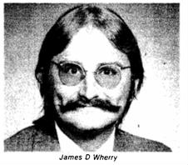
James D. Wherry combined genealogical, ethnographic, and ethnohistorical data with a thorough knowledge of the contemporary Maliseet
sociopolitical system and Bureau of Indian Affairs federal regulations to obtain federal and state recognition for the 350 members of the Houlton Band of Maliseets of Maine. His efforts also helped enable the Houlton Band establish eligibility to share in the Maine Indian Land Claim, which yielded them
$900,000 to purchase trust land.
✵
Honorable Mention: Leonard Borman

Clients: Self-Help Groups, Small-Scale Voluntary Organizations, Private and Public Agencies, Professionals, and the Media

Establishment of the Self-Help Center in Evanston, Illinois
Leonard Borman’s project 1) helped those who wished to establish self-help groups or clearinghouses in their regions, 2) assisted those involved in self-help groups in such areas as leadership, group development, network formation, and fostering effective relations between the groups and appropriate professional agencies, 3) expanded knowledge about self-help groups regarding their origins, reasons for development, ways individuals become involved, group processes, and impact, 4) published and distributed materials designed

for the public and professional awareness of self-help/mutual aid, and 5) developed an information exchange system enabling groups, potential participants, professionals, and social agencies to learn of each other’s existence, needs, activities, and locations.
✵
Honorable Mention: Thomas F. King and Patricia L. Parker
Client: Government of the Trust Territory of the Pacific Islands

Intercultural Mediation at Truk International Airport

The government of the Trust Territory of the Pacific Islands planned to expand its airport in Truk, an island group in the central Caroline Islands. The people of the two villages adjacent to the area targeted for construction objected: They feared the project would destroy traditional fishing areas and important cultural landmarks, as well as take land and food resources for which the villagers felt they would not be properly compensated. As a result, the government faced increasing civil disobedience and threats of litigation by the villagers. Anthropologists served as mediators between the parties in the confrontation.
✵

Honorable Mention: Charlotte I. Miller and Hector Martinez
Client: United States Agency for International Development

Social Soundness Analysis, Central Selva Natural Resources Management Project, Peru

This project involved the investigation of two broad questions: 1) Has the population of the region already reached a level where a substantial influx of new colonists would place undue stress on the carrying capacity of the land? and 2) Does the project area qualify as a potential “breadbasket” for Peru, as is believed by a number of key policy makers? Miller and Martinez viewed their goal as conducting a useful study while involving all the concerned groups in the research design and fieldwork phases in order to mitigate in-group versus out-group conflict.
✵
Honorable Mention: Joseph Nalven and Community Research Associates: Michael

M. English, David M. Fetterman, and Keith
V. Bletzer

Client: San Diego County Board of Supervisors

Measuring the Unmeasurable: a Microregional Study of an Undocumented Population

Beginning in 1974, the Board of Supervisors of San Diego County, California, wanted to know more about the numbers and impacts of undocumented international immigrants within the boundaries of their county, which borders Mexico. Despite two in-house studies (1975, 1977) and a resolution calling for legislative action, the Board had been unable to convince the federal government to provide special impact funds to deal with the costs incurred by the county due to the
presence of undocumented immigrants. With the impending visit of the Congressional Select Commission on Immigration and Refugee Policy to the West Coast in June 1980, the Board decided to have another impact study conducted that it could present to the select commission along with, and in support of, the Board’s own policy recommendations. This time the supervisors wanted an outside group to conduct the research: Their goal was to have a scientifically defensible study with which to advocate for the local community perspective.

✵

Honorable Mention: Kevin Preister and the Foundation for Urban and Neighborhood Development

Clients: Hospital Builders Equipment and Colorado Joint Review Process

Issue-Centered Social Impact Assessment

The proposal to develop Adam's Rib Recreational Area in Colorado was made in the context of important physical and economic changes that were already having profound social consequences. The project was first proposed in 1972, but for a number of reasons it became bogged down in controversy. Hospital Builders Equipment (HBE) re-activated the proposal in late 1979. The developer and the responsible agencies agreed that the project would be reviewed under the auspices of the Colorado Joint Review Process. This process was developed by the state to coordinate the review of major development projects among the various responsible agencies and government levels for the purpose of avoiding the duplication of efforts and the delays characteristic of development decisions. Participation in the review process was voluntary, and the existing legal authority of each entity was not superseded. This model was later used to review major mining and oil shale projects.

✵
Honorable Mention: Mary G. Rust

Client: Bureau of City Planning, Tampa, Florida

Introduction of a Human Services Element into the Local Comprehensive Plan

The goal of the project was to introduce a human services element into the local comprehensive plan of the Bureau of City Planning in Tampa, Florida. Rust worked to integrate human services by utilizing the natural pattern of organization (i.e., networks) that characterized human service organizations. She succeeded in drawing together those segments that reflected shared concerns about particular needs within the community to promote sharing information, conducting research, and planning cooperatively.

✵
Honorable Mention: Richard Scaglion

Client: Papa New Guinea’s Law Reform Commission

Customary Law Development in Papua New Guinea

Papua New Guinea is well known for its cultural diversity. In a country of some three and one-half million people, there are at least 750 mutually unintelligible languages and probably about a thousand different customary legal systems. Amid such diversity, would it be possible to uncover basic legal principles common to all these Melanesian societies? If so, could the essence of Melanesian customary law, which functions smoothly in small-scale tribal societies, be reconciled with the requirements of a modern nation-state? To investigate these issues on a long-term basis, the Papua New Guinea
government established a Law Reform Commission as a constitutional body. The commission hoped that some of the problems with the interim legal system could be resolved through this project that designed and used an ongoing research strategy to gather information on customary law patterns of different tribes, analyze the data, identify problem areas, and help create draft legislation designed to alleviate such problems.
✵
Honorable Mention: Martin D. Topper

Clients: Navajo Area Office of the Indian Health Service and Other Federal, State, and Tribal Agencies

Federal Joint Use Area Relocation: Applying Clinical Anthropology in a Troubled Situation

Public Law 93-531 mandated that approximately 10,000 Navajos would have to relocate from 900,000 acres of reservation land in northeastern Arizona. The anthropologist had three objectives. First, he had to gather data on problems experienced by relocatees and potential relocatees, including difficulties with relocation housing, issues in adjusting to off-reservation relocation homes, difficulties caused by mandatory livestock reduction in Federal Joint Use Areas (FJUAs), and problems arising from a freeze on new construction in the FJUA, as well as stress caused by continuing Hopi-Navajo lawsuits and uncertainty generated by new regulations and modifications of the relocation law. Second, he had to assess the possible needs of relocatees and potential relocatees for services of the Navajo Area Office of the Indian Health Service (NAIHS) mental health clinics. And, finally, he had to provide consultation to NAIHS and other federal, state, and tribal agencies on reducing potential negative impacts of relocation to

manageable proportions. Topper’s broad role required the employment of a range of traditional and applied anthropological skills.
✵
Honorable Mention: M.G. Trend and J. W. Frees

Client: Employment and Training Administration, United States Department of Labor

The Evaluation of the Minnesota Work Equity Project
The purpose of the evaluation of the Minnesota Work Equity Project was to test a new approach for reducing welfare dependency among populations served by the Aid to Families with Dependent Children, General Assistance, and Food Stamps programs. To do this, a coordinated “bundle” of services was to be provided by a state
agency. The services included counseling, training in vocational programs, on-the-job training, and subsidized jobs. The experimental program was unusual in the variety of clients it served and the rich mix of services rendered in an essentially mandatory program. The challenge was to document this comprehensive project as it was implemented at several sites and to compare outcomes with those of existing service programs, including the Work Incentive, General Assistance Work Programs, and Comprehensive Employment and Training Act. The evaluation project utilized economic, survey, and anthropological techniques.

Praxis Award Directors: Robert Wulff, Shirley Fiske, and Carole Tyson
Jurors: Erve Chambers, Mary Elmendorf, Ruthann Knudson, Fred Richardson, Janet Schreiber, and Sol Tax

1982

Winner: Gerald F. Murray

Clients: Pan American Development Foundation and United States Agency for International Development

Haitian Agro-Forestry Outreach Project

Murray designed and administered the project, which succeeded in convincing Haitian peasants to reforest their lands by giving them ownership over the newly planted trees. The notion was met with enthusiasm, and in less than a year, 2500 peasant households in more than a hundred communities planted over one million trees.
✵
Honorable Mention: Margaret S. Boone

Clients: Units of Federal and Local Government, National Science Foundation, Children’s Defense Fund

Practicing Socio-Medicine: Redefining the Problem of Infant Mortality in Washington, D.C.

Boone conducted research and public liaison/action on the sociocultural causes and prevention of infant mortality. In Washington, D.C., babies were dying in their first years of life at the highest rate for any large American city, and nobody could figure out why. The Mayor's Blue Ribbon Committee on Infant Mortality actively reviewed the city's policies and programs for pregnant women. This project on the infant mortality problem was funded separately by the National Science Foundation, so it was first and foremost a scientific research project. However, it also included a strong effort to make research results known to political participants. The result was a shift in the definition of the infant mortality problem away from a strictly medical model and
toward a broader framework that included a better understanding of social and cultural behavior.
✵
Honorable Mention: Judith R. Davidson

Clients: United States Agency for International Development and Ministry of Health of Peru

The Delivery of Rural Reproductive Medicine in Peru
Davidson completed a client-oriented evaluation of the national midwife training program in Peru which provided solutions to the problem of training indigenous health providers. In Peru, instruction of traditional birth attendants (TBAs) in Western techniques of maternity care had been going on sporadically since 1945. In 1979 TBA training became a national priority and training courses were set up in all of Peru’s 16 health regions. Resources for TBA training were an important segment of the United States Agency for International Development (USAID) investment of over $17 million provided to the Peruvian Ministry of Health (MOH) for the promotion of community health in rural and semi-urban populations. The MOH measured the success of the program by the numbers of patients treated by trained TBAs, but it did not consider TBAs' reactions to the training course or the patients' reaction to the trained TBAs as important determinants of program outcome. The USAID project included the grassroots reaction to the program in designing its evaluation.

✵

Honorable Mention: George S. Esber

Client: Tonto Apache Indians of Payson, Arizona

Designing Apache Homes with Apaches

Native Americans, since the time of first contact, have listened to unsolicited opinions about their homes and been subject to Anglo attempts to change their living conditions. The U.S. government has continued to judge Native American homes unilaterally as inadequate and/or substandard and to pursue policies to re-house Native Americans in Anglo-style housing. This approach has been followed without regard for Native American needs as dictated by cultural traditions or the architectural designs necessary to accommodate them. Rarely have Native Americans even been queried about their preferences for house types. The goal of the Payson Project was to correct this problem by honoring Indian self-determination with respect to the home and community design for a new Tonto Apache camp.

✵
Honorable Mention: Edward C. Green
Clients: United States Agency for International Development and Swaziland Ministry of Health

The Planning of Health Education Strategies in Swaziland

The primary purpose of the study was to provide baseline data for the design of a national health education strategy aimed at reducing the incidence of waterborne diseases in Swaziland. The project paper (the main planning document for the project) called for further anthropological contributions: the identification of potential human resources for the delivery of health education, the designation of traditional
opinion leaders and informal communications networks, the identification of patterns of visual literacy and perception, and the acquisition of knowledge about Swazi ethnomedical theory and practice.
✵
Honorable Mention: Michael M. Horowitz and the Institute for Development Anthropology

Clients: United States Agency for International Development, World Bank, and Food and Agriculture Organization of the United Nations

Development of Pastoral Livestock Production Systems in Africa and the Near East

This project was concerned with the development of pastoral livestock production systems in Africa and the Near East. Goals included: 1) conducting a series of workshops both in the United States and Africa involving pastoral livestock specialists, donor organization officers, and African government officials who are responsible for the implementation of livestock development projects, 2) writing a series of discussion and policy papers highlighting the importance of an anthropological contribution in the livestock development planning process, and
3) making select field investigations to inform project personnel on ways in which project performance might be improved and to indicate the relevance of social anthropological field data in livestock development planning.

✵

Honorable Mention: William L. Leap

Client: Northern Ute Tribe, Northeastern Utah

Tribally-Controlled Culture Change: The Northern Ute Language Renewal Project
Loss of language skills is always associated with losses in other areas of social and cultural life, and replacements for such details, regardless of their emotional appeal, may not always restore continuity or stability within these cultural domains. The problem at issue in this project was twofold: Ute language loss and the need to effectively counteract it. Leap helped to restore Ute language fluency by integrating tribal priorities/institutions with structural and social linguistics. This project offers an example of ways in which responses to losses in language and cultural tradition can be effectively implemented.

✵
Honorable Mention: Stephen C. Maack Client: St. Paul Planning, St. Paul, Minnesota St. Paul Displacement Study
In this project, Maack used qualitative and quantitative measurement and public dissemination of the socioeconomic impacts of residential displacement caused by inner city revitalization. The displacement study detailed how many St. Paul residents were displaced between 1970 and 1979, what their social characteristics were, the causes of their displacement, where they went, and what data trends suggested for the future.
✵
Honorable Mention: John P. Mason

Clients: United States Agency for International Development and Botswana Ministry of Local Government and Lands

Promoting Socioculturally Feasible Housing and Community Upgrading Programs in Botswana

Mason created a demonstration program to illustrate the mesh of technical, social, and financial elements needed for the successful production of self-help housing in Botswana. Urban growth in Botswana in the mid-to-late 1970s was proceeding at a very high rate of 12 percent. To respond to this situation, the Government of Botswana had invited the U.S. foreign assistance arm, the United States Agency for International Development (USAID), to help. USAID in turn asked the Cooperative Housing Foundation to provide technical assistance in arriving at a solution to the rapid urban growth problem. The result of this collaborative effort was the development and successful completion of an innovative, self-help urban shelter and community-upgrading program. This program accommodated the housing demand of a growing population of squatters who were illegally occupying land in shanty structures they built on the fringes of Botswana's towns. It also met that demand in such a way that the houses and public facilities and services developed under the program were adapted to the socioeconomic and cultural conditions of low-income Botswana families.
✵

Honorable Mention: Allen C. Turner

Clients: Kaibab Band of Paiute Indians in Arizona and United States Department of Housing and Urban Development

The Kaibab-Paiute Community Research and Development Program
Turner created a comprehensive community planning process on the Kaibab Paiute reservation that maximized citizen participation amid cross-cultural and intra-community conflicts. The tribal council lacked participation on the part of the community members; community members felt left out of decision-making. Part of the challenge was to design a planning process that would maximize citizen participation in a small-scale community with fluctuating composition and population and one in which factional dispute seemed to be the basis for decision-making. Substantive problems identified and subsequently addressed through comprehensive community planning
included constructing adequate housing for all reservation residents, providing sufficient safe water to all homes, redesigning the entire village for future growth, and improving the nature and quality of health care.
Praxis Award Directors: Robert Wulff and Shirley Fiske
Jurors: Erve Chambers, Annetta Cheek, George Foster, Setha Low, and James Wherry
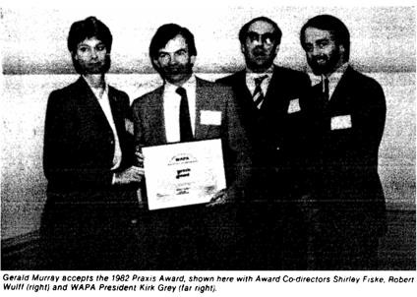

1983

Winner: Rebecca Hagey

Client: Native Canadian Friendship Centre, Toronto, Canada

Native Diabetes Education Program

Hagey conducted participatory action research on diabetes in the native community, which led to the establishment of the aboriginal community health centre. Native peoples of the Americas have been recognized as having the highest incidence and prevalence of diabetes in the world. The Native Diabetes Program was faced with the task of changing native attitudes and responses to the disease, as diagnosis was believed to trigger separation from spouse, job abandonment, drinking problems among those who previously drank moderately or not at all, difficulties with the law, and rapid onset of physical complications of diabetes. The means of changing beliefs and attitudes and of preventing complications was to set up a self-help diabetes education and research center and draw on cultural strengths in the Ojibway and Cree heritage.
✵
Honorable Mention: Billie R. DeWalt, Kathleen DeWalt, and Edward C. Reeves

Client: United States Agency for International Development

The International Sorghum/Millet Research Project

Sorghum and millet are important food grains in many lesser developed countries (LDCs); yet the socioeconomic constraints on their production and use are poorly understood. In this project, a group of economic and ecological anthropologists based at the University of Kentucky conducted a multilateral agricultural research project
sponsored by the United States Agency for International Development. The anthropological contribution has been to study farming systems of small scale, limited-resource agricultural producers in LDCs that are highly dependent on sorghum and millet for food.

✵
Honorable Mention: Edward C. Green

Client: Swaziland Ministry of Health

Developing Cooperation between the Traditional and Modern Health Sectors in Swaziland

This project consolidated previous research findings and collected further information in order to provide Swaziland’s Ministry of Health with an assessment of 1) manpower in the traditional health sector, 2) the areas and extent of cooperation possible between the traditional and modern health sectors, with special reference to diarrhoeal diseases, 3) the extent to which alternative systems are developing for the consumer, with special reference to the influence of traditional healers in areas where there are Rural Health Motivators, 4) legislation, customary law, and government policy regarding traditional healing and healers, 5) possibilities for the development of a National Traditional Healer’s Association, and the role of government in promoting, monitoring, and liaising with such an association, 6) the potential for the paraprofessional training of certain types of traditional healers, and 7) additional information needed in the area of traditional healing.
✵

Honorable Mention: Stanley E. Hyland and the Center for Voluntary Action Research
Client: 1981 Memphis Jobs Conference

Linkage Building for Neighborhood Development in Memphis, Tennessee

This project developed a linkage system between neighborhood-based organizations, intermediate agencies (both public and private), and the business community. The linkage was achieved through open meetings and specific invitations. In addition, Hyland and the Center for Voluntary Action Research (CVAR) took the neighborhood development goal to other agencies, groups, and vested interests. In the linkage process, CVAR developed a methodology where information could be exchanged, and then gaps in information could be identified and addressed by Memphis State University anthropology faculty and students through CVAR or through public agencies. In effect, the approach to solving the client’s problems was to quickly move away from a single agent approach as well as to negotiate with a variety of vested interest groups at each step of the neighborhood development process.
✵
Honorable Mention: Richard Lerner

Client: United States Army Corps of Engineers

Preserving Plants for Pomos

The 1969 National Environmental Policy Act requires both the government and the private sector to "preserve important historic, cultural and natural aspects of our national heritage, and maintain, wherever possible, an environment which supports diversity and variety of individual choice." The U.S. Army Corps of Engineers sponsored cultural investigations in association with the planning of a large dam and reservoir. Although not recognized by its initial studies,
the Corps' later cultural surveys, which included ethnographic and ethnohistorical research, determined that Mihilakawna, Makahmo, and descendants of other Pomoan tribelets had continued to utilize the project area for collecting plants used for economic, ritual, and medicinal purposes. Of special importance was that Pomoan basket weavers still selectively harvested and made extensive use of rhizomes (reproductive roots) from a certain species of sedge (Carex barbarae) found within the project area. The Corps' challenge was to find alternative sources of the plant materials and/or to establish the plants in new locations.
✵
Honorable Mention: Robert T. Trotter
Clients: Sunrise Community Health Center, Greeley, Colorado, and a Private Corporation

A Case of Lead Poisoning from Folk Remedies in Mexican American Communities

Three sources of lead poisoning most commonly affect children in the United States: eating lead-based paint chips, living and playing near smelters where the dust contains elevated levels of lead, and eating off of improperly treated lead-glazed pottery. This project resulted from the discovery of a fourth source of lead poisoning among children: ingestion of the high lead content powders azarcón (orange) and greta (yellow) used in Mexican American communities to treat the folk illness empacho, manifested by abdominal discomfort and diarrhea. Trotter’s objective was to develop culturally-sensitive health awareness materials that would reduce the risk of people consuming these powders without attacking or denigrating the folk medical system itself.

Praxis Award Directors: Robert Wulff and Shirley Fiske. Jurors: Steven Barnett, Jean Schensul, and Dorothea Theodoratus

1985

Co-Winner: Julianne Duncan

Client: Catholic Community Services of Tacoma, Washington

Developing Foster Care for Cambodian Orphans in Tacoma

The goal of this project was to develop a foster care program with related services for Cambodian orphans entering the United States from refugee camps in Southeast Asia. By the time of their departure from the foster care program, youths should be economically self-sufficient. Duncan used Cambodian cultural norms and worldviews as a basis for helping the orphans to build successful lives in America. Emphasis was placed on using the excellent local educational and health resources and on developing program elements for helping the children overcome the traumatic emotional effects of their loss of family and culture during their war and migration experiences. Cambodian ritual and curing experts were major resources as well.

Co-Winner: Stanley E. Hyland

Client: Center for Voluntary Action Research, Memphis State University, Memphis, Tennessee

Improving Weatherization Services for Low Income Communities
In response to public criticism of increasing utility bills, Memphis Light, Gas, and Water (MLG &W), like many utility companies, began to implement energy conservation programs in 1977. However, it did not successfully communicate its programs to its low-income customers—the population segment most in need of utility assistance. The goal of the Center for Voluntary Action Research weatherization project was to redesign the delivery of an existing program
to more effectively meet the needs of low-income Memphis communities.
✵
Honorable Mention: Virginia Lee Barnes-Dean

Client: International Rescue Committee

Diagnosis of Scurvy in Lower Gedo, Somali, Refugee Camps in 1982
The International Rescue Committee (IRC) is a small, non-profit refugee assistance organization formed in 1933. Barnes-Dean was hired to go to Somalia and see what the IRC could contribute to the healthcare of refugee camp inhabitants. Her project concerned the diet of the refugees and its relative adequacy in protein, calories, and vitamins A and C. Because the only vitamin C-containing part of the diet was dates/raisins, all of which were stolen before food deliveries reached the camp, IRC staff administered vitamin C. However, when they explained they had conducted a trial of administering Vitamin C with aspirin added for the relief of pain, Barnes-Dean made the successful diagnosis of scurvy, noting that while aspirin would relieve the pain of afflicted individuals, as an anti-coagulant it would also counteract the beneficial nutritional effects of vitamin C. Four patients were flown to the capital of Mogadishu, where their long bones were x-rayed and signs of scurvy and other syndromes were detected.

✵

Honorable Mention: Olivia Cadaval, Leslie Prosterman, Nancy Riker, and Brett Williams

Client: Mount Pleasant Advisory Neighborhood Commission, Washington, D.C.

Mount Pleasant Traditional Arts Workshops

Washington’s Mount Pleasant neighborhood possessed rich possibilities for becoming a model of racial, economic and cultural integration. Yet, gentrification and the influx of refugees contributed to increasing tensions in the area. The design of the Mount Pleasant Traditional Arts Workshops included process along with product as part of its mandate. At the outset, a community organizer, an anthropologist, and two folklorists leafleted and telephoned people in the neighborhood and invited interested parties to participate in the planning of the events. Over a period of four months, community members became active organizers and designers of the project.
✵
Honorable Mention: Anthony DiBella

Client: Foster Parents Plan International

Establishing an Effective, Expanding Research Department for a Major International Development Organization

In 1979, Foster Parents Plan International (PLAN) had 28 programs in 19 countries, but the organization lacked any means of knowing how effective its programs were or the most efficient way to deliver services. Di Bella’s project was to establish a system to monitor and evaluate programs on a worldwide basis. The challenge was to create an independent yet responsive research bureau that would allow International Headquarters to monitor projects and develop higher quality programs with greater impact while also meeting daily requests
from field staff for consultation on various research and program design tasks, such as conducting baseline studies and identifying cultural barriers to development.
✵
Honorable Mention: LTG Associates: Neil Tashima, Cathleen Crain, and Fred Gretenhart

Client: Lao Family Community of Fresno, California

Development of a Southeast Asian Refugee Mutual Assistance Association: Bridging Cultures and Producing Results

Lao Family Community (LFC) of Fresno requested LTG Associates to provide technical assistance in assessment, organizational development, fund-raising, and short- and long-term planning. The stated purpose of the collaboration was to ensure that LFC would develop into a competitive service provider, be able to provide appropriate services to the community, and could eventually become independent of governmental monies in order to ensure its survival.
✵
Honorable Mention: Patricia Mariella

Client: Fort McDowell Indian Community in Arizona

Orme Dam Social Impacts

The Fort McDowell tribal council hired Mariella as a consultant to monitor the social impact assessment portion of the Orme Dam and Alternatives Control Study of the Central Arizona Water Control Study (CAWCS). The proposed Orme Dam to be built by the Bureau of Reclamation would have flooded most of the reservation and required the relocation of

the community members. The tribe opposed the dam. Mariella’s project ensured that the social impact assessment portion of the CAWCS was thorough and accurate, and it assisted the tribe in effectively presenting the reasons for its opposition to the proposed dam to the non-Indian public and key decision-makers.
✵
Honorable Mention: Corinne Shear Wood

Clients: Centre for Maori Studies and Research, University of Waikato, New Zealand, and a Community of Maori People

Introduction of Health Self-Help in a Maori Population

The goals of the project were several: 1) to alleviate a situation in which Maori people were suffering decreased life expectancy as well as unnecessary morbidity due to inadequate utilization of existing medical facilities; 2) to reinstill in the indigenous population a sense of its own work; and 3) to propose a facility acceptable to the Maori people and likely to receive some support from established government agencies.
✵

Honorable Mention: Grace Zilverberg and Anita Courtney

Clients: Lexington-Fayette Urban County Vice-Mayor Pam Miller, the Fayette County Health Department, and the Kentucky State Department of Agriculture

The Status and Potential of the Fruit and Vegetable Market in the Kentucky Bluegrass Region

With the loss of price supports threatened by the Reagan Administration and increased competition from Third World producers of tobacco, farmers in Kentucky were searching for an alternative to that crop. While the state’s climate is favorable for most crops, its hilly topography limits the economies of scale necessary for some. Additionally, the market infrastructure for fruits and vegetables in Kentucky is severely underdeveloped. The purpose of this project was to assess interest in and the potential for developing a market for fruits and vegetables in the Kentucky Bluegrass Region.

Praxis Award Directors: Robert Wulff, Shirley Fiske, and Charles Cheney
Jurors: Carol Stack, Gwen Stern, Hazel Weidman, and John van Willigen

1987

Winner: Robert E. Rhoades

Client: International Potato Center, Lima, Peru

Agricultural Anthropology at the International Potato Center

Rhoades developed a farming systems research model through an alternative approach to solving farm-level technological problems that begins and ends with the farmer. Early in the process, tests involving new plants, animals and technologies are researcher managed with the cooperation of the farmers. Later, the experimental program is managed by the farmers. The on-farm experiment stage improves the researchers’ understanding of the farming system and increases the integration of the farmer into the research process. The testing phase emphasizes the evaluation of technical improvements in an area under farmer control, and it is geared toward fine-tuning the technology in response to farmer needs, constraints, and management practices.
✵
Honorable Mention: Joan M. Campbell

Project client, title, and abstract not recorded.
✵
Honorable Mention: Peter C. Hainer, Camilo Garcia, David Ward, and Catherine Hines

Client: United States Bureau of the Census

Using Ethnographic Research to Design Advertising Strategies for the 1990 Census
In 1987, the U.S. Bureau of the Census, working with the advertising agency Ogilvy & Mather, sought to develop a national promotional campaign for the 1990
Decennial Census that would increase minority participation in the ten-year count. Catherine Hines directed this effort from the Census Bureau’s Center for Survey Methods Research and collaborated with Ogilvy & Mather’s David Ward, and together they enlisted the aid of two ethnographers, Camilo Garcia (UCLA) and Peter Hainer (Curry College), to help them understand how to design advertising strategies for minority communities. Garcia conducted interviews and observational studies among Hispanics in Los Angeles and eastern Washington State assessing barriers to Census credibility and offering suggestions for the kinds of messages that might overcome them. Hainer carried out parallel fieldwork and interviews with low-income Black families in Boston and prepared a report stressing the real risks that respondents could run by reporting actual behavior and the factors that might influence their decisions on whether to report or suppress the counting of certain family members. Because Garcia and Hainer worked with informants who knew and trusted them, the ethnographers were able to provide Ogilvy & Mather with useful findings that informed their promotional plan with regard to (1) negative perceptions of advertising and Census Bureau behaviors that could impede accurate counting in minority communities,
(2) minority community beliefs, attitudes and behaviors that bore on relative willingness to participate, and (3) campaign-associated images, language or persons likely to elicit cooperation. The richness of the ethnographic data gave the Ogilvy & Mather staff a sense of working directly with real people and issues, and the project was able to effectively demonstrate the value of ethnography to the Census Bureau.
✵

Honorable Mention: Robert D. Hicks

Client: Virginia Department of Criminal Justice Services

Time Crime: Protecting the Past for Future Generations

The investigation of looting poses serious challenges for law enforcement officers. In Virginia, without an archeologist’s assistance, an officer would find it very difficult to process a crime scene or present a case for prosecution, since an archeologist is needed to describe what has been disturbed, vandalized, or recovered, as well as to make a value assessment of on-site damage or of recovered looted artifacts. Therefore, the Virginia Department of Historic Resources and the Virginia Department of Criminal Justice services produced a model policy on the theft of historical resources, and Hicks implemented a training program called “Time Crime” that acquainted law enforcement officers with the looting problem, reviewed applicable state and federal laws, and outlined an investigative protocol modeled closely on federal procedures honed through prosecutions. As a result of the training, many investigations occurred, and increasing numbers of consultations between officers and archeologists took place. Virginia’s example demonstrates that, despite differences between state and federal laws, investigative methods developed through cases in other states can be adapted to local circumstances, and anti-looting laws that go uninforced owing to lack of knowledge can be revived if local law enforcement officers are provided the proper investigative tools and encouraged to use them.

✵
Honorable Mention: Madelyn Anne Iris

Client: Metropolitan Chicago Coalition on Aging

Research and Policy Contributions in the Study and Treatment of Elderly Abuse

Iris carried out a two-year ethnographic study of the implementation of a project concerning the identification and treatment of elder abuse in north suburban Cook County. She then disseminated the research findings through presentations to the Illinois Department on Aging and via a range of publications and presentations to professional groups at national, state and local conferences. Several book chapters based on the study were published.
✵
Honorable Mention: Linda L. Lampl

Client: Gulf & South Atlantic Fisheries Foundation, Tampa, Florida

Fishing, Economics and Politics in the Gulf Waters of Florida

In the wake of the mid-1980s culinary craze for New Orleans-style blackened redfish, public alarm was generated by media accounts of commercial fishermen dangerously depleting the Gulf of Mexico’s previously abundant supply of that species by overfishing with dragnets, and sports columnists claimed that commercial fishermen were taking all of the redfish and thereby threatening Florida’s recreational fishing industry and its important contribution to the state’s economy. With a background of ethnography among the commercial fishing families of Florida’s Pine Island, Lampl undertook participant-observation and government document research into the controversy in 1986, and the following year, in the face of marked recreational fishing industry hostility, she

dissemination information via television and print media, as well as through testimony to the Governor’s cabinet, that countered the inaccurate rapacious portrayals of commercial fishermen and noted that the records revealed that in fact they took only 12 percent of the annual redfish catch, as against
88 percent by recreational fishermen. Nonetheless, the economically-powerful recreational fishing industry prevailed in the Florida legislature, which banned net fishing in the state’s waters, thus dooming the livelihood and lifeway known to generations of Florida’s coastal fishing families.
✵
Honorable Mention: Lynda L. Layne and Willett M. Kempton
New Jersey Gas and Electric Utilities and New Jersey Department of Commerce

Ethnography of Consumer Energy Information
Through the conduct of in-depth ethnographic interviews, Layne and Kempton learned how New Jersey residential energy consumers measure and analyze their own energy consumption and energy costs, and they found that the consumers conducted more extensive data collection and analysis than previously documented in the energy literature. Layne and Kempton recommend a more efficient allocation of data collection and analysis between consumers and energy utilities.

Praxis Award Committee: Cathleen Crai (Chair), Fred Gretenhart, John Mason, and Jessica Scheer

Jurors: Conrad Arensberg, Elliot Liebow, Priscilla Reining, and Susan Scrimshaw

1989

Winner: Michael R. Dove

Client: United States Agency for International Development

The Anthropological Component in Pakistan Forestry and Development

The purpose of the first large social forestry project in Pakistan was the development of an effective extension service to help rural households become self-sufficient in fuel, timber and fodder. Dove’s task, as project anthropologist, was to help the forest service identify and communicate with the intended clientele, who were to be the farmers with small holdings. It was thought that they were unwilling to plant trees. Field research revealed, however, that it was not farmer aversion that was the obstacle, but rather the aversion of foresters to working with small farmers. As a result, Dove shifted part of his emphasis from communicating forestry technology to farmers to communicating farmers’ attitudes and needs to foresters, and from motivating farmers to plant trees to motivating foresters to help farmers plant trees. This project’s lesson was that the object of development, the small farmer, is by no means the only—or often even the major—obstacle to development.
✵
Runner-Up: Steven A. Romanoff

Client: Centro Internacional de Agricultura Tropical

Anthropology Helps Small-Scale Farmers Establish Organizations to Process and Sell Cassava in Coastal Ecuador
Centro Internacional de Agricultura Tropical (CIAT) asked for research on factors limiting the spread of its post-harvest technology for processing cassava among farmers on the
North Coast of Colombia, which they were disseminating with the Integrated Rural Development program of the Government of Colombia. After a year of research among farmers and government functionaries (financed by a Rockefeller post-doc fellowship), the results came in: The main limitation on spreading the technology was the cost of technical assistance, not the expense of the cassava processing technology itself. The extension effort was being carried out by government and international experts, who taught farmers about the technology and, more importantly, helped them start and maintain farmer organizations. The lessons drawn from the research were to build on technical success by providing more efficient and effective technical assistance at lower cost using mechanisms like mixing farmer-to-farmer technical assistance with government extension, reliance on easy-to-form associations (rather than legalistic cooperatives), appropriate use of second-order organizations with a segmentary structure (as observed by anthropologists), correct siting of farmer organizations by using both natural and social geographic data in geographic information systems (GIS), etc. Next, CIAT provided seed finance to try applying these lessons in coastal Ecuador. Efficient farmer organizations, farmer-to-farmer technology transfer with Ministry extensionists, use of GIS, etc., all contributed to the founding of profitable farmer organizations at low cost. Further, the second-order Union of Associations of Cassava Producers and Processors proved viable, and two women's groups joined in.
✵

Honorable Mention: Madelyn Anne Iris Client: Illinois Protective Service Coalition Guardianship of Older Adults
Based on an ethnographic evaluation of a model program for low-income Chicago elderly, Iris documented her efforts to increase professional awareness of and knowledge about the Illinois guardianship system. She also analyzed more than 600 judicial decisions in elderly guardianship in Illinois. Iris then applied her extensive findings in working as a consultant to the Steering Committee of the Illinois Protective Service Coalition and in helping to launch a National Guardianship Association.
✵

Honorable Mention: Hope L. Isaacs, Claire Gulino, Mary Anne Sweeney, and Mary Ann Small

Client: United States-Mexico Border Health Association

Promotion of Breast-Feeding Practices in a Binational Population
A team of American and Mexican anthropologists and nurses identified key factors involved in widespread inadequate feeding methods and associated health problems of infants of first-time Hispanic mothers in the San Diego-Tijuana border area. These problems were addressed through the use of culturally-relevant computer-based educational interactive programs installed in maternal-child health clinics on both sides of the international border.
✵
Honorable Mention: LTG Associates: Cathleen Crain and Niel Tashima
Client: Southeast Asian Refugee Community Leadership, Orange County, California

Development of an Effective Immigrant Community Development Organization

LTG was requested to provide assistance in the design and development of a mental health service program adapted to the cultural and linguistic needs of recently arrived Southeast Asian immigrants and refugees in Orange County, California. The project evolved to the point where the goal of the consultation became rendering technical assistance and guidance to the leadership so that a free-standing, non-profit service entity representing all Southeast Asian refugee groups in Orange County would emerge as a viable organization. The result of this effort was a community development corporation: The Orange County Community Resources Opportunity Project. Following its establishment, this corporation provided vital social services to thousands of county refugees and immigrants—and served as a model for other programs across the United States.

Praxis Award Committee: Leslie Ann Brownrigg and Cathleen Crain (Co-Chairs), Gerald Britan, Muriel Crespi, and Ruth Landman

Jurors: Lucy Cohen, Katherine Spenser Halperin, Peter Hammond, Twig Johnson, and Priscilla Reining

1991

Winner: Michael K. Orbach and Jeffrey C. Johnson
Clients: Gulf and South Atlantic Fishery Development Foundation, National Marine Fisheries Service, Florida Sea Grant College Program, and the State of Florida

An Industry-Derived Management Program for the Florida Spiny Lobster Fishery: An Anthropological Approach to Science and Public Policy Making
The management of the spiny lobster fishery in the Florida Keys provided a great example of how an issue of the commons can be resolved with the participation of various stakeholders. Orbach and Johnson worked with the commercial fishing industry, recreational fishermen, environmental interests and others to solve the problem of having too many traps in the water. With the input of fishermen and other stakeholder
representatives, they gathered a wide range of quantitative and qualitative data about the issue through participatory observation, mail surveys, and personal interviews. The program, which required new Florida legislation to implement, was actually lobbied for by the stakeholders—commercial, recreational and environmental. Through this broadly participatory processes, the main goal was reached: The number of traps was reduced by more than half while the catch remained relatively constant, increasing the overall profitability of the fishery, reducing conflict, and making the fishery more easily manageable.

Praxis Award Committee: Leslie Ann Brownrigg and Mark Schoepfle (Co-Chairs), Gerald Britan, Shirley Buzzard, and Claire Cassidy

Jurors: John Farella, Shirley Fiske, Richard Stoffle, and Wayne Warry

1993

Co-Winner: Diana Briton Putman

Clients: United States Agency for International Development and Water User Associations in Tunisia

An Anthropological Approach to Policy Reform: The National Strategy for Potable Water User Associations in Tunisia
Putman demonstrated the effective use of anthropological methods and theory in designing and implementing policy reform efforts. This project for the development of the national strategy to create and monitor water user associations in Tunisia was developed during a two-week period from February 5 to 16, 1990, by a United States Agency for International Development (USAID) team representing Water and
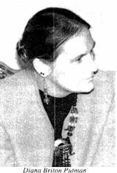
Sanitation for Health, Irrigation Support Project for Asia and the Near East, and Systems Approach to Regional Income and Sustainable Resource Assistance. It was initiated by the
USAID/Tunisia Mission and built on USAID/Tunisia's
ongoing support for improving rural water supplies in Tunisia. Since1986, USAID had provided support for the Rural Potable Water Institutions Project in Kasserine and North Gafsa Governorates. One of the objectives of the project was to demonstrate a model for increasing beneficiary participation that may be appropriate for adoption as a nationwide strategy. Anthropological contributions included a holistic, integrated approach to solving development problems rather than a narrow technical focus, as well as a participatory approach involving local people in the design and implementation of all stages of the work. Anthropologists played key roles
in facilitating multidisciplinary cooperation throughout the project.
✵
Co-Winner: Cathy Small

Clients: Individual Artisans, Reservation-Based Cooperatives, and Indian Community Organizers

Southwest Arts and Artists

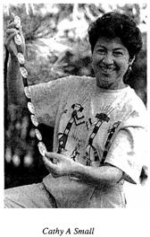
This project, initiated in 1989, sought to increase the sales of Native American art from Northern Arizona in both domestic and overseas markets. Its aims were to increase the income that Native American artisans received from their
work (particularly during the slow winter months), to educate the buying public about Native art and artisans, and to promote the establishment of local, Indian-owned entities for the production, marketing, and sale of Indian art. Project
results included the creation of domestic and overseas craft catalogs, generation of income for more than 70 artists, production of a 25-minute documentary video on Southwest Indian arts and artists, and support of six Indian-owned artisan cooperatives or businesses.
✵

Special Recognition: Dawn Bodo and Ryan Wahlstrom

Video: Of Hands and Hearts: Indian Arts & Artists of the Southwest
Praxis Award Committee: Ruth Cernea (Chair), Cathleen Crain Laurie Krieger, Ruth Landman, Ann Leonhardt, and Merrily Stover

Jurors: Karen Hanson, Jack Marshall, Michael Orbach, and William Partridge

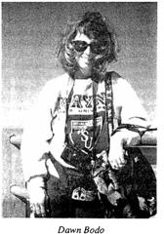

1995

Winner: Edward H Greeley and Project Team: Allison B Herrick, Rosalie Fanale, Satish Shah, Spencer Silberstein, and Helen Soos
Clients: United States Agency for International Development and Government of Kenya

Design of the Kenya Private Sector Family Planning Project
Greeley and his colleagues employed anthropological methodologies in the design and implementation of the Kenya Private Sector Family Planning Project, which resulted in widespread adoption of family planning and an unprecedented decline in fertility rates in the region. Locally-based, nongovernmental approaches of the kind pioneered under this early model project were increasingly adopted by donor agencies and endorsed by governments worldwide.

✵

Honorable Mention: Mac Chapin and Project Team: Nicanor Gonzalez, William Threlkeld, and Others

Clients: General Congress of the Emberá, Wounaan and Kuna People and Centro de Estudios y Acción Panameño

Participatory Mapping in the Darien Region of Panama

In order to assist the indigenous people of Panama’s densely-forested Darien Region protect their land rights from the incursions of outsiders, Chapin and the project team recruited a group of “surveyors” from local communities, trained them in land-use questionnaire and cartographic techniques, and deployed them throughout the region. The intent was to carry out an ethnocartography in which the local people
would create their own maps with their own symbols. The surveyors, in collaboration with village elders, made detailed drawings of river systems, hunting, fishing and gathering areas, and the locations of medicinal and other forest products. They then joined with University of Panama cartographers to use the official government base maps to construct composite maps. However, the product was a countermap: Place names, river systems, and significant local landmarks were all recorded on a master map in the native languages. With the master map in hand, the Darien inhabitants addressed a forum in Panama City, and the forum participants induced Panama’s Minister of Government and Justice to officially recognize the importance of indigenous land rights.
✵
Special Recognition: Elizabeth Briody and Dawn Bodo

Client: National Association for the Practice of Anthropology

Anthropologists at Work: Careers Making a Difference
This 36-minute color video describes a wide variety of anthropological careers. Conceived by members of the National Association for the Practice of Anthropology, a section of the American Anthropological Association, the video is directed at students and other members of the anthropological community. Its purpose is to provide up-to-date information on the range of careers associated with all major subfields of anthropology.

Praxis Award Committee: Ruth Cernea (Chair), Cathleen Crain, Mari Clark, Laurie Krieger, and Merrily Stover. Jurors: Michael Agar, Karen Hanson, G. Alfred Hess, Joyce Justice, and John van Willigen

1997

Winner: John C. Kolar and Elizabeth M. Salter
Client: Medical City Dallas Hospital, Dallas, Texas

Craniofacial Anthropometry

A generation ago, children with congenital deformities of the head and face had very little hope of ever leading a normal life. They were rejected by their peers and society in general, and within their families they often became withdrawn and isolated. A major stumbling block to the use of craniofacial anthropometry has historically been a lack of standardization of measurement techniques, which makes it difficult to compare results from one biological anthropologist to another. To address this problem, Kolar and Salter wrote Craniofacial Anthropometry: Practical Measurement of the Head and Face for Clinical, Surgical, and Research Use (Springfield, IL: Charles C. Thomas Publisher, 1997), which clearly describes and illustrates the anthropometric techniques used by the authors.
✵

Honorable Mention: William R. Brieger, Sakiru A. Otusanya, Ganiyu A. Oke, Frederick O. Oshiname, and Joshua D. Adeniyi

Client: African Programme for Onchocerciasis Control

Community-Directed Treatment with Ivermectin in Oyo State, Nigeria
Community-directed distribution with ivermectin (CDTI) was adopted by the African Programme for Onchocerciasis (River Blindness) Control as its main strategy for achieving sustained high coverage in endemic communities. CDTI was introduced in four
local government areas in Oyo State, Nigeria. Using a household survey after the second distribution, researchers documented that
68.8 percent of the community overall received the drug, as did 85 percent of those who were eligible (not pregnant, not sick, and at least five years of age). In-depth interviews with village elders and volunteer community-directed distributors, together with focus group discussions among villagers, provided qualitative data to help interpret the findings. Women in many villages felt excluded from decision making. Also, the concerns of migrant Fulani farm workers living in Yoruba farm settlements were not well understood by health staff or the majority population. The main factor associated with receiving the ivermectin was having received it before, and qualitative comments about side-effects and beliefs about orthodox drugs indicated that issues of personal preferences, not addressed in the household coverage survey, need to be explored further. These findings can provide guidance in re-orienting health workers to the importance of fostering participation and cohesion among all segments of the community, especially the inclusion of women and minority groups.
✵
Honorable Mention: Maria Donoso Clark

Client: World Bank

Tuberculosis Control Project, India

The Government of India implemented a new national strategy to arrest the spread of tuberculosis. The World Bank-funded Tuberculosis Control Project used social assessment as an "umbrella" approach to 1) collect and analyze the socioeconomic data needed for project preparation and design, 2) create an innovative strategy for stakeholder involvement in project planning and activities, including a tribal peoples' action

plan, and 3) develop appropriate social indicators for the project.
Praxis Award Committee: Laurie Krieger and John Mason (Co-Chairs), Ruth Cernea, Ruth Landman, Rebecca Miller, and Lois Keck

Jurors: Names not recorded.

1999

Winner: Virginia D. Nazarea

Clients: International Potato Center's Asia Regional Office in Los Baños, Philippines, the Southern Seed Legacy Program, and the Sustainable Agriculture Research and Education Program, United States Department of Agriculture

The Memory Banking Project

The international genetic resources community has developed an elaborate network of gene banks to preserve biological diversity for use by plant breeders. The "memory banking" project, formulated in the context of an International Potato Center Asian network and later extended to the southern United States and Ecuadorian Andes, has successfully complemented these germplasm efforts by introducing the practical importance of also preserving the cultural knowledge of traditional peoples who are the original in situ biodiversity curators. The complexity and challenge facing the memory banking project lay in developing a protocol by which traditional knowledge could complement biological information, convincing biological scientists of the value of such knowledge, and then extending the protocol methodology to real world situations.
✵
Honorable Mention: Robert T. Trotter and International Research Team
Client: World Health Organization

Cross-Cultural and International Application of Anthropological Theory and Methods to the Revision of the International Classification of Impairments, Disabilities and Handicaps
The World Health Organization determined that its original classification system was unworkable cross-culturally. It therefore funded this project carried out by Trotter and a research team composed of members from the United States, Canada, Turkey, India, Germany, and Sweden. A variety of anthropological and linguistic approaches and theories were used to develop and refine categories more applicable cross-culturally. Among them were (1) a translation-back translation process backed by linguistic analysis of key terms; (2) a pile-sorting technique developed in cognitive anthropology to determine classification structure; (3) a concept mapping technique to allow for individual item analysis of cultural sensitivity, gender and age bias, place in classification, and need for inclusion; and (4) focus group interviews.

✵
Special Recognition: Shirley Buzzard and Heartland International Team
Clients: Various Businesses and Non-Profit Organizations

The Corporate Community Investment Service
Shirley Buzzard and the Heartland International Team created the Corporate Community Investment Service (CorCom), which comprised a set of techniques and tools for getting businesses and non-profit organizations—often considered antagonists—to work together on joint ventures and produce win-win outcomes. The problem lay in linking organizations with different values and operational modes in joint ventures that would benefit local communities. For example, in Mexico, CorCom made it possible for maquiladora factory employee families to become both more productive and more healthy by

arranging for them to be provided with basic but important necessities: factory-based child care for working mothers, on-site school instruction and healthy meals for working teens, and building materials other than the usual shantytown cardboard for the construction of nearby homes.
✵
Special Recognition: Richard L. Warren

Client: Homeless Day Care Center, San Luis Obispo, California

Dispute Mediation Through Community Action: A Day Care Center for the Homeless
The anthropologist was instrumental in the leadership of volunteer groups assisting the homeless in San Luis Obispo, California, beginning in 1991. Warren viewed the process of establishing and operating the day care center as a field site, with participant observation leading to action-enhancing communication via sensitivity to differences in the cultural stances and concerns of the stakeholders, including volunteer group members and the homeless themselves.

Praxis Award Committee: Mari Clarke (Chair), Antoinette Brown, Ruth Cernea, Ruth Landman, Laurie Krieger, William Roberts, and Patrick Thomas
Jurors: Elizabeth Briody, Muriel Crespi, Manindar Gill, James Nations, and Barbara Pillsbury

2001

Co-Winner: Judith Freidenberg
Client: Mt. Sinai Medical Center, New York, New York

Exhibiting Anthropological Data on Elderly in the United States
Freidenberg conducted extensive anthropological fieldwork among elderly Latinos in the low-income urban enclave of East Harlem, New York City, under a service policy contract with Mount Sinai Medical Center. The client raised two interrelated points regarding how best to employ this wealth of information: 1) How could anthropology be used to provide an understanding of the challenges and constraints encountered by this population to a wide spectrum of stakeholders? and 2) Might that shared understanding impact local-level policymaking? The project addressed those points by eliciting insights on social issues from informants using applied methodologies, curating a museum exhibit to disseminate these insights to diverse sectors of the national society, and facilitating the communication of grassroots perspectives to policy makers.
✵
Co-Winner: Kathryn A. Kozaitis

Clients: Atlanta, GA, Public Schools and a Consortium of Seven Atlanta-Area Colleges and Universities

The Elementary Science Education Partners Project
Elementary Science Education Partners (ESEP) was a joint project of the Atlanta, Georgia, Public Schools (APS) and a consortium of seven Atlanta-area colleges and universities. The project goal was the
systemic reform of Atlanta K-5 science education over five years. The novel feature of this project was participatory reform: the praxis paradigm informed by the anthropological theory of participatory development and ethnographic, participatory action research methods. This approach was conceived, designed and directed by Kozaitis, who served as a direct change agent in each component and at every level throughout the life of the project.
✵
Special Recognition: Elisa J. Sobo
Client: Children’s Hospital San Diego, California

Evaluation of an Outreach and Education Campaign for Healthy Families Program/Medical for Children

In 1998, California launched Healthy Families/Medical for Children (HF/MCC). The program provided low and no-cost insurance to low-income children. Seventy-two community based organizations (CBOs) received awards for culturally-appropriate outreach and enrollment activities. Awarded contracts were performance-based and required measurable outcomes. The evaluation of CBO performance was contracted by the Children’s Hospital San Diego (through the San Diego State Foundation). This created the opportunity to include an anthropologically- informed telephone interview component aimed at collecting qualitative data from front-line CBO staff members. The goal of the resulting report was to positively impact health services for California’s poorer families.

Praxis Award Committee: Antoinette Brown and Mari Clarke (Co-Chairs)
Jurors: Names not recorded.

2003

First Prize Co-Winner: Sara Quandt and Thomas Arcury
Clients: National Institute for Occupational Safety and Health, North Carolina Department of Agriculture & Consumer Services and Bureau of Primary Healthcare, Albert Schweitzer Fellows Program, and Private Corporations

Reducing the Impact of Green Tobacco Sickness among Migrant and Seasonal Farmworkers

Quandt and Arcury conducted first-time ethnographic work on Green Tobacco Sickness (GTS) in rural North Carolina. They then created culturally-appropriate educational materials to help farmworkers to avoid acquiring GTS, and they produced pertinent information for medical personnel treating patients suffering from this syndrome.

✵
First Prize Co-Winner: Susanna Price
Client: Asian Development Bank

Enhancing National Involuntary Resettlement Policy Standards for the Asia Region

Price’s employment of anthropological approaches yielded critical case studies documenting the social and economic costs entailed under circumstances of involuntary resettlement in Asia. This project’s outcomes achieved international and national recognition for eight country resettlement plans, and it set standards for addressing such situations in the future.
✵
Second Prize: Melanie Bush

Client: Brooklyn College, Brooklyn, New York

The Community Building Initiative

This project involved Brooklyn College, an educational institution in a densely urban setting with an enormously diverse student population representing 120 countries. Using anthropological methods of inquiry and application, Bush established the Community Building Initiative. The project engaged campus stakeholders in dialogues and programs, and it influenced pertinent institutional policies.
✵
Third Prize: Claire M. Cassidy

Client: Office of Alternative Medicine, National Institutes of Health

Translating Medicine: An Anthropologist Examines the Growth of Complementary and Alternative Medicine
Cassidy’s approach was threefold: 1) use of ethnographic and survey methods to assess the status of acupuncture practitioners in the United States, 2) integration of anthropological insights into the production of a textbook on Chinese medicine for use by American biomedical students, and 3) utilization of qualitative methods to examine how complementary and alternative medicine practitioners explain their work to recipients of their healthcare.
✵

Honorable Mention: Denis Foley

Clients: Governor’s Traffic Safety Council, New York State Stop DWI Coordinators’ Foundation, Sheldon & Ruth Goldstein Foundation, New York State Press Association Foundation, and Local Newspapers

Friends Gallery Exhibit

This project involved the use of anthropological methods of collecting, cataloging and describing/displaying an individual’s material culture as a means for understanding the individual’s personality. The context was that of college-aged students involved in fatal automobile accidents as a result of drinking alcohol, usually perceived as an integral part of college life.
✵
Honorable Mention: Harold D. Green

Client: Cooperative for Assistance and Relief Everywhere (CARE)

Food Aid Management Constituency Study

The United States Agency for International Development supports much development assistance through grants to non-governmental organizations (NGOs). Five such NGOs created a collaborative model for studying and enhancing capacity development, called the Food Aid Management (FAM) consortium. Green’s project employed ethnography, social network analysis, and quantitative analysis to describe interactions among FAM member groups, and it developed indicators of FAM’s impact on capacity development.

WAPA Praxis Committee: Antoinette Brown and Willis Sibley (Co-Chairs)
Jurors: Margaret Eisenhart, Carl Kendall, John Van D. Lewis, Pamela Puntanny, and Robert Rhoades

2005

No Praxis Award Competition entries were submitted in 2005.

2007

Winner: LTG Associates: Niel Tashima, Cathleen Crain, Michael French Smith, Alberto Bouroncle, and Kerry Weeda

Client: World Health Organization

Evaluation of the Collaborative Fund

LTG Associates was awarded a contract from the World Health Organization (WHO) to undertake a project involving the monitoring and evaluation of the organization and effectiveness of programs related to HIV treatment, patient self-involvement, and health literacy within a very complex program involving some 150 WHO grantees in 65 countries representing an enormous variety of cultures and societal arrangements. The focus of the LTG project was WHO’s grant to The Collaborative Fund for Treatment Preparedness.
Honorable Mention: Susan Andreatta

Client: Carteret Catch

Developing Alternative Markets for Small-Scale Commercial Fishermen
The purpose of Andreatta’s project was to help establish new markets for small-scale commercial fisherman in Carteret County, North Carolina. Fishermen in the area were getting involved in directly marketing their seafood products through a program known as “Community Supported Fisheries” modeled after community-supported agricultural arrangements. These fishermen were also part of a branding endeavor known as Carteret Catch, a trademarked logo that helped to identify locally-landed seafood products. Combining the Carteret Catch branding program with Community Supported Fisheries will help the public to identify which roadside stands, fish houses, and restaurants are serving local seafood, thus providing a way for the public to play an active role in sustaining the 400-year-old-fishing heritage of the county’s coastal communities, fishermen, and fish house dealers.

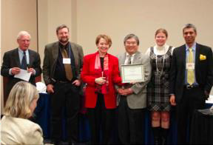
Left to right: Will Sibley, 2007 Praxis Award Chair, Rob Nunn, WAPA President, and 2007 Praxis Award inners LTG Associates: Cathleen Crane, Nathaniel Tashima, Kerry Weeda, and Alberto Bouroncle

✵
✵
Honorable Mention: Lynellyn D. Long

Clients: Women-to-Work and Serbian Non-Governmental Organizations and Businesses

Women-to-Work: Project to Assist Survivors of Domestic Violence in Serbia and Beyond
Due to high rates of unemployment in Serbia, many young men and women have migrated from home. For women, informal and black market employment is common, especially in sexual services and the entertainment industry. Upon returning home, these women often suffer sexual violence and exploitation.

Anthropologist Long secured philanthropic and other sources of support and developed a system of training for new employment and learning entrepreneurial skills, mentoring, and developing new micro-enterprises. In order to succeed in her plans, she employed critical anthropological skills in researching the context in which her subject women clients must survive and in developing
training and mentoring programs consonant with their needs and developing goals.
Praxis Award Committee: Willis Sibley and Robert Wulff (Co-Chairs)

Jurors: Edward B. Liebow, J. Anthony Paredes, David Rymph, and John van Willigen

2009

Co-Winner: Robbie Blinkoff, Tracy Johnson and the Context-Based Research Team: Belinda Blinkoff, Leah Kabran, Chuck Donofrio, and Stephanie Simpson
Client: Associated Press

A New Model for News: Studying the Deep Structure of Young-Adult News Consumption
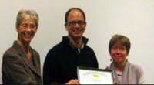
Shirley Fiske presents the Praxis Award to Robbie Blinkoff and Tracy Johnson of the Context-Based Research Group

This project was implemented to help the Associated Press (AP) understand the way young people learn about news globally, especially in a digital era. Blinkoff and the Context-Based Research Team used anthropology to get behind peoples’ behaviors to the cultural values and individual motivations that inform the younger generation’s use of news media. They did this through intensive ethnographic study of 18 cases across three continents, which in the end provided more valuable insights and had more impact on AP’s marketing strategies than the reams of data coming out of national surveys and quantitative economic reports.
✵
Co-Winner: Barbara Pillsbury

Client: United Nations Population Fund

Anthropology in Action: An Anthropologist’s Role in Restoring United States Support for the United Nations Population Fund
This endeavor entailed the restoration of U.S. government funding for the global work of the United Nations Population Fund (UNFPA). In 2002 the Bush Administration rescinded American support based on allegations that UNFPA was complicit in forced abortions and sterilizations in China. Pillsbury was firmly convinced that, on the contrary, UNFPA was a major force in promoting reproductive choice and volunteerism in China’s family planning program and that the United States should support UNFPA. Her anthropological investigations and activism during 2003-2009 established a strong evidence base. Success came in early 2009 when President Obama and the U.S. Congress agreed to refund UNFPA.
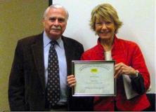
Charles Cheney gives the Praxis Award to Barbara Pillsbury

✵

Honorable Mention: Alan Boraas

Clients: Kenaitze Tribal Members and Alaska National Heritage Center

Preservation and Renewal of the Kenaitze Dialect of the Athabaskan Language of Dena’ina

When the last native speaker of Kenai died, tribal leaders feared linguistic and cultural extinction, and they turned for help to Alan Boraas. Working in close collaboration with tribal members, he organized this participatory action research project around the Sapir-Whorf Hypothesis—that language influences thought—and employed a creative combination of methods, including orthography, story translations, archeology, and ethnogeography. To return their language and culture to the Kenaitze, he crafted an innovative and sophisticated website that included online texts, spoken language tapes, oral stories, images illustrating culturally significant stories and places, and audio recordings of the last speakers of Kenai. The website is now successfully reaching into each and every Kenaitze family home 24 hours a day as tribal members access the site to learn their language and culture.

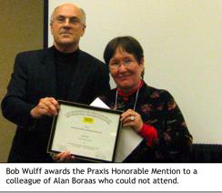

✵
Honorable Mention: LTG Associates: Cathleen Crain and Niel Tashima
Client: World Health Organization

Decent Care: Shifting the Health Care Paradigm

Crain and Tashima advanced the notion that decent care goes beyond health entitlement, and they are leading a World Health Organization (WHO) effort to build health systems based on the values of Decent Care. The challenge of this project was to explore the concept of Decent Care through the respectful engagement of all stakeholders and to move through a process of development and refinement to a series of exploratory implementation steps. The anthropologists focused on a process of group interactions to develop a sense of community that would function in a multicultural environment.

Praxis Award Committee: Charles Cheney (Chair), Shirley Fiske, Terry Redding, and Robert Wulff

Jurors: Erve Chambers, Philip Herr, John Mason, and Janet Schreiber
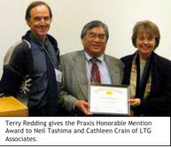

2011

Winner: Amanda Stronza

Clients: Native Community of Infierno; Rainforest Expeditions

Posada Amazonas: A Partnership for Ecotourism in the Peruvian Amazon

Posada Amazonas is a community-based ecotourism lodge in the Peruvian Amazon. It was built in 1996 as a joint venture between the Native Community of Infierno, a village of
150 families, and Rainforest Expeditions, a private tourism company. The partners split profits and agreed to co-manage the lodge for 20 years. Community members work not only as boat drivers, cooks, and guides, but also as directors, owners, and decision-makers in the company. Successes to date include substantial economic returns for the community, local stewardship of forests and wildlife, and a variety of social benefits,
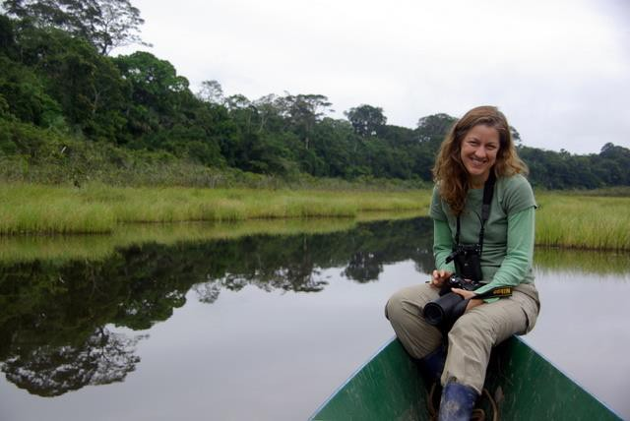
including strengthened community organization and local autonomy. For nearly two decades, Stronza has collaborated closely with both partners to gauge economic, social, cultural, and environmental impacts. Few ecotourism projects have been so carefully documented using the tools of anthropology. Stronza has shared the story of Posada Amazonas in the popular media, public presentations, and a documentary film. In 2003, she directed a series of tri-national workshops with indigenous leaders in similar community-based ecotourism projects in Bolivia and Ecuador. For its achievements in
connecting conservation and development, the Posada Amazonas project has earned many international awards, including recognition by the United Nations Development Programme Equator Initiative.
✵
Honorable Mention: Adam Koons

Client: U.S. Agency for International Development

Afghanistan Vouchers for Increased Production in Agriculture

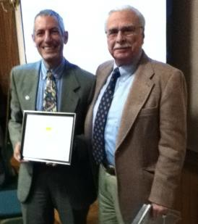
In 2008, Koons, an anthropologist working for an international NGO, co-designed a $60 million one-year emergency agricultural recovery program for northern Afghanistan in response to drought and increasing food insecurity. Through local knowledge and cultural sensitivity, and through consultation with and involvement of local communities, the project maintained local dignity, self-determination, and participant ownership, while enhancing local productive relationships. At its
conclusion, the program had assisted 341, 301 small farms
(1.7 million persons) to regain their own food security. This was the largest project of its kind ever implemented by the
U.S. Government. The project’s success led to its expansion within Afghanistan and time extensions that continue to 2011.
Praxis Award Committee: Charles Cheney (Chair), Judith Freidenberg, Terry Redding, Gretchen Schafft, and Robert Wulff

Jurors: Suzanne Heurtin-Roberts, John Mason, Katy Moran, and George Roth

Recipient Index

A
Andreatta, Susan · 31
Arcury, Thomas · 28

B
Barnes-Dean, Virginia Lee · 11
Bletzer, Keith V. · 2 Blinkoff, Belinda · 33 Blinkoff, Robbie · 33 Bodo Dawn · 22 Bodo, Dawn · 21 Boone, Margaret S. · 5 Boraas, Alan · 34 Borman, Leonard · 1
Bouroncle, Alberto · 31 Brieger, William R. · 23 Briody, Elizabeth · 22, 26 Bush, Melanie · 28 Buzzard, Shirley · 25

C
Cadaval, Olivia · 12 Campbell, Joan M. · 14 Cassidy, Claire M. · 28 Cathleen Crain · 12, 18, 31
Center for Voluntary Action Research · 10, 11
Clark, Maria Donoso · 23 Community Research Associates · 2 Context-Based Research · 33 Courtney, Anita · 13
Crain, Cathleen · 34

D
Davidson, Judith R. · 5 DeWalt, Billie R. · 9 DeWalt, Kathleen · 9 DiBella, Anthony · 12 Donofrio, Chuck · 33 Dove, Michael R. · 17 Duncan, Julianne · 11

E
English, Michael M. · 2
Esber, George S. · 6

F
Fanale, Rosalie · 22 Fetterman, David M. · 2 Foley, Denis · 29
Foundation for Urban and Neighborhood Development · 2
Frees, J.W. · 4
Freidenberg, Judith · 27

G
Garcia, Camilo · 14 Gonzalez, Nicanor · 22 Greeley, Edward H. · 22 Green, Edward C. · 6, 9 Green, Harold D. · 29 Gretenhart, Fred · 12 Gulino, Claire · 18

H
Hagey, Rebecca · 9
Hainer, Peter C. · 14 Heartland International · 25 Herrick, Allison B. · 22 Hicks, Robert D. · 15
Hines, Catherine · 14 Horowitz, Michael M. · 6 Hyland, Stanley E. · 10, 11

I
Institute for Development Anthropology · 6
Iris, Madelyn Anne · 15, 18
Isaacs, Hope L. · 18

J
Johnson, Jeffrey C. · 19
Johnson, Tracy · 33

K
Kabran, Leah · 33
Kempton, Willett M. · 16

King, Thomas F. · 1 Kolar, John C. · 23 Koons, Adam · 35 Kozaitis, Kathryn A. · 27

L
Lampl, Linda L. · 15 Layne, Lynda L. · 16 Leap, William L. · 7 Lerner, Richard · 10 Long, Lynellyn D. · 31
LTG Associates · 12, 18, 31, 34

M
Maack, Stephen C. · 7 Mariella, Patricia · 12 Martinez, Hector · 2 Mason, John P. · 7 Miller, Charlotte I. · 2 Murray, Gerald F. · 5

N
Nalven, Joseph · 2
Nazarea, Virginia D. · 25

O
Orbach, Michael K, · 19

P
Parker, Patricia L. · 1 Pillsbury, Barbara · 33 Preister, Kevin · 2 Price, Susanna · 28 Prosterman, Leslie · 12
Putman, Diana Briton · 20

Q
Quandt, Sara · 28

R
Reeves, Edward C. · 9 Rhoades, Robert E. · 14 Riker, Nancy · 12 Romanoff, Steven A. · 17 Rust, Mary G. · 3

S
Salter, Elizabeth M. · 23 Scaglion, Richard · 3 Shah, Satish · 22 Silberstein, Spencer · 22 Simpson, Stephanie · 33 Small, Cathy · 20
Small, Mary Ann · 18 Smith, Michael French · 31 Sobo, Elisa J. · 27
Soos, Helen · 22
Stronza, Amanda · 35
Sweeney, Mary Anne · 18

T
Tashima, Niel · 18, 31, 34 Threlkeld, William · 22 Topper, Martin D. · 3 Trend, M.G. · 4
Trotter, Robert T. · 10, 25
Turner, Allen C. · 8

W
Wahlstron, Ryan · 21 Ward, David · 14 Warren, Richard L. · 26 Weeda, Kerry · 31 Wherry, James D. · 1 Williams, Brett · 12
Wood, Corinne Shear · 13

Z
Zilverberg, Grace · 13

Recognizing Excellence in Practitioner Anthropology

2015 PRAXIS AWARD RECIPIENTS
WAPA is pleased to announce the four recipients of the 2015 Praxis Award. Two Awards and two Honorable Mentions were presented at the NAPA Business Meeting during the annual meeting of the American Anthropological Association in November in Denver, CO.

Mari Clarke and team are the co-winners of the 2015 Praxis Award for their competition entry: "Improving Awareness and Technical Skills in Road Maintenance within the Third Rural Transport Project, Vietnam."

Project Client: World Bank

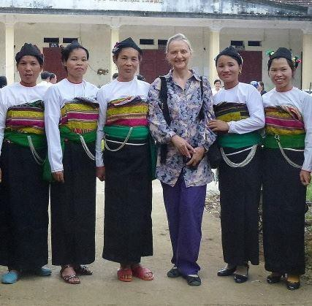

Mari Clarke and members of her rural project team.

The application described how this ethnic minority road maintenance effort in Vietnam was managed by women’s unions in three provinces in coordination with provincial, district, and commune transport and people’s committees. The project addressed the isolation of rural, ethnic minorities who lack road access, and was able to mobilize and raised awareness of 765,000 people. The project increased market, school, and health care access to local groups while also increasing the social capital, status, and voices of community women who maintained the roadways. The approach of including local ethnic women in
maintenance efforts fostered a “culture” of road stewardship and also influenced institutional change in the national Ministry of Transport. The anthropologist applied a holistic analytical framework and ethnographic methods in monitoring and evaluation to document and promote the approach, and to foster both a bottom-up and top-down “culture” of road maintenance changes.

Comments from a Praxis juror:

"The outcome was clearly successful in terms of improvement of transportation together with several desired consequences like economic improvement and gender equity. In fact, I hope the applicant does an article at some point with more detail on the change in gender linked behavior as a function of the project, slowly and over time. It feels from the necessarily brief description like a fascinating and useful story. The application of anthropological skills is described in several different aspects of the project."

Mari H. Clarke is a World Bank Senior Gender Consultant with over 30 years of addressing gender in international development (transport, energy, water, environment, agriculture, microenterprise, monitoring and evaluation). She has been a World Bank consultant on gender and transport since 2005.

Stephen Weidlich and the AECOM team are also co-winners of the 2015 Praxis Award for their entry, "Little Saigon Design Guidelines" in San Diego, CA.

Project client: Little Saigon Foundation; El Cajon Business Improvement Association
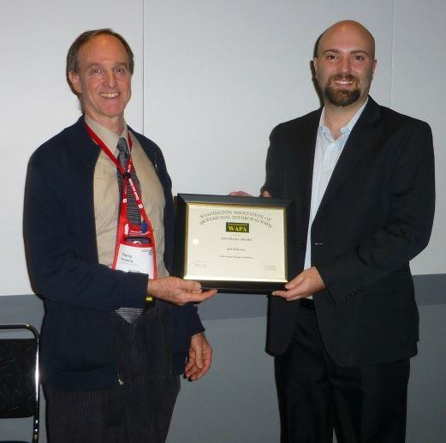

Stephen Weidlich (right) receives the Praxis Award from award committee chair Terry Redding

As described in the application, the Little Saigon Design Guidelines project was a collaborative effort between urban planners, outreach specialists, and anthropologists to help create a set of design guidelines that would
establish a cohesive identity and culturally relevant public space for a Vietnamese business district in San Diego, California. Outreach events, including an innovative photo documentary and discussion activity, served to explore and record the ideas, goals, and concerns about the neighborhood while being sensitive to the diversity of businesses and residents in the surrounding residential community. The design guidelines synthesized the community vision, provided thoughtful design recommendations, and defined actionable steps for realizing a new ethnic business district called “Little Saigon.”

Comments from a Praxis juror:

"The applicant, an anthropologist with an engineering and consulting firm, formed part of a team to
produce a plan for development of “Little Saigon” in San Diego. He introduced several ethnographic-type

approaches from anthropology and other fields to obtain interactive community participation throughout, the “participant photography workshop” being a central one. A plan with “actionable next steps” was produced and earned a planning award and letter of commendation."

Mr. Weidlich is a cultural anthropologist and ethnographer at AECOM, Inc., a global engineering and consulting company, providing social impact assessment services for federal, state, and local clients, as well as private clients in the alternative energy industries.

There were also two honorable mentions for the 2015 Praxis Award.

LTG Associates, Inc. has received an honorable mention for a project titled "Pastors at Risk: Toward an Improved Culture of Health for United Methodist Clergy in North Carolina"

Project client: The Duke Endowment

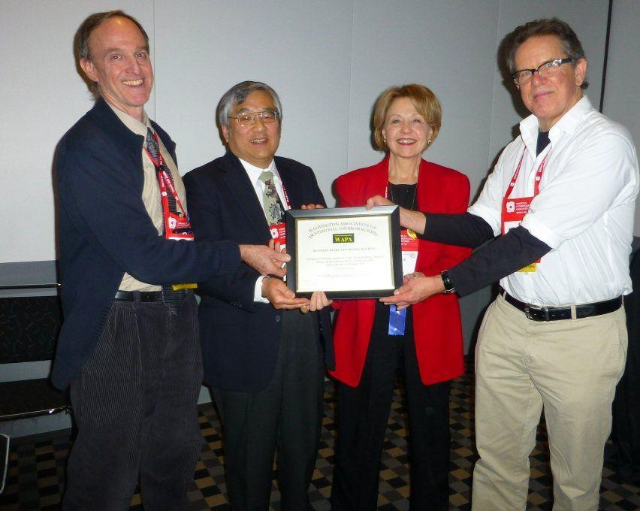

LTG Associates team members Terry Redding, Nathaniel Tashima, and Cathleen Crain receive an honorable mention certificate from 2013 Praxis Award winner Mark Edberg.

The application described LTG’s multiyear evaluation work focusing on the Duke Divinity School’s Clergy Health Initiative (CHI). The CHI sought to improve the overall health of some 2,500 United Methodist
pastors in North Carolina. LTG’s use of anthropological methods and engagement allowed the team to provide critical information that informed the shape and functioning of the CHI intervention with clergy. LTG also documented individual improvements in clergy health, but more importantly, witnessed and documented positive shifts in the culture of health within the larger United Methodist Church hierarchy and community in North Carolina.

Comments from a Praxis Juror:

"Initially I wasn’t sure because it sounded like an applied research evaluation for the funder separate
from the actual hands on program implementation. As I read I saw that they had turned “evaluation” into a hands-on anthro-style organizational development process, with serious and ongoing engagement with all stakeholders, iterative and interactive changes in program in part due to their collaborative work, and well documented positive outcomes in terms of health awareness and practices."

Members of the LTG Associates project team included Cathleen Crain, Nathaniel Tashima, Terry Redding, Reiko Ishihara-Brito, Michelle Wilson, Kristen Hudgins, Jillian Brems, and Pamela Rao.

Federico Cintrón-Moscoso, working with the Centro Para La Conservación Del Paisaje (Center for Landscape Conservation) in Puerto Rico, has received an Honorable Mention for the project “Public Participation in the Revision of El Yunque National Forest Management Plan.”

Project Client: El Yunque National Forest, USDA Forest Service

This 2.5-year project takes place within the context of revisions to the El Yunque National Forest’s management plan and recent changes in federal regulations, which allow for greater public input into the planning process. Despite the policy changes, the historical, political, economic, and cultural context of Puerto Rico, a colonial territory of the United States since 1898, presented a barrier to incorporating viewpoints of the public. Utilizing anthropological theories and methodologies, the team identified some of the challenges presented by these barriers—including historically top-down, scientific-based decisionmaking, public mistrust in administrators, gaps in knowledge regarding visitor practices, and lack of interest from some sectors of the public—and developed a locally appropriate and relevant strategy to address the challenges.

Comments from a Praxis Juror:

"This project first of all deals with a core issue for anthropological practitioners, not to mention managers, namely, how to integrate “stakeholders” and “ manager” in a useful way. The applicant
demonstrates the contribution of his background from general concept to detailed strategy. It is clearly a team effort as reflected in the description. The results are impressive in how the project connected the managers with local communities in several ways and in the many appended statement by colleagues he worked with."

Federico Cintrón-Moscoso, along with his work with the Centro Para La Conservación Del Paisaje, is adjunct professor of research methods at the Department of Graduate Studies, School of Education (UPR), and has been an applied consultant since 2008. He specializes in community-based participatory action research, youth and community development, environmental education, and public participation in natural resource management.

Award Jurors and Committee

WAPA would like to express deep appreciation for the tremendous amount of work done by the 2015 award jurors, who thoroughly examined the many applications received and provided thoughtful comments and ratings for the award:

Michael Agar helped establish the MAA program at U Maryland (where he is emeritus professor), has authored several books, runs his own consulting firm, Ethknoworks LLC, and is a research professor at U New Mexico.

Dominique Desjeux, professor emeritus in the Anthropology Department at the Sorbonne in Paris, founded a French social anthropology professional network called AnthroPik, and runs an international consulting firm, Daize and Co.

Tracy Meerwarth Pester, a business anthropologist who worked as a contractor for General Motors for several years, has worked in recent years to modernize anthropological ethics statements to more closely align with the actual work done by practicing anthropologists.

The Praxis Committee consists of Shirley Buzzard, Jenny Masur, Stan Yoder, and Terry Redding (chair).

Recognizing Excellence in Practitioner Anthropology

2013 PRAXIS AWARD RECIPIENTS
WAPA is pleased to announce that Mark Edberg has won the 2013 Praxis Award for his competition entry:Using the Concept of Social Well-Being to Develop and Implement a Framework for UNICEF Planning and Evaluating Efforts to Achieve Rights and Development Goals for Children, Youth and Families.
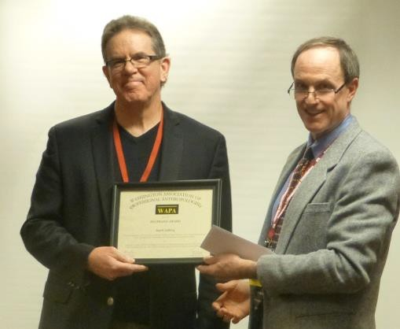

Photo: Mark Edberg received the 2013 Praxis Award and stipend from Praxis Chair Terry Redding.

The application described Edberg's collaboration with UNICEF to develop and implement a holistic, multi-domain, social well-being model as a basis for planning and monitoring progress, where social well-being is understood as a precursor to the rights and development goals UNICEF promotes and monitors. The application described two aspects of Edberg's efforts: 1) the Adolescent Well-Being Framework developed for UNICEF Latin America-Caribbean, being tested in several sites and used in developing a UNICEF global survey module on adolescents; and 2) the Social Well-Being Framework used as the basis for a national situation analysis of women, children and youth in Belize, a five-year action plan, and for follow-up work to implement recommendations from the analysis.

Edberg's work demonstrates a strong and successful application of qualitative methods typically used in anthropology in a setting usually dominated by quantitative methodologies, and shows a pragmatic

approach to developing a comprehensive body of relevant indicators. His work was selected for the 2013 Praxis Award for demonstrating the value of using these anthropological methods in a large-scale, cross-disciplinary setting. In addition, these methods have been adopted by UNICEF for additional projects, making the potential impact and benefit of his work with UNICEF far-reaching. The applicant also successfully navigated several meetings with NGO and government officials to show the utility of the proposed framework, and worked through several steps with UNICEF to ensure project success.

Comments from one of the Praxis jurors help relate why Edberg was selected for the award:

“This impressive application describes how Edberg has integrated anthropological theory and methodology into the development of UNICEF's Adolescent Well-Being Framework. His account describes several years' worth of committed engagement with stakeholders, resulting in a series of useful and usable tools that UNICEF continues to use in planning, implementing and evaluating development efforts.”
Dr. Edberg is with the George Washington University School of Public Health and Health Services (SPHHS), with secondary appointments in the Department of Anthropology and Elliott School of International Affairs.

The competition in 2013 was exceptionally strong. Thus, there are three additional Honorable Mention winners for this award cycle.

Honorable Mention: Madelyn Iris and Rebecca L.H. Berman have earned a 2013 Praxis Award Honorable Mention for their competition entry: Local Evaluation of Caring Together, Living Better: Engaging Churches in Caregiver Resource Development in Cook County, IL

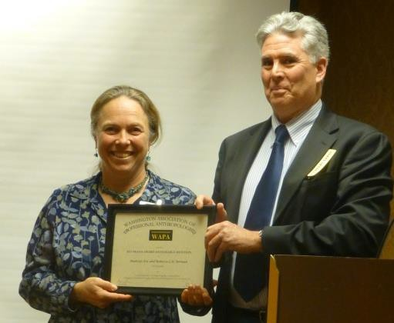

Photo: Rebecca L.H. Berman receives the Praxis Award Honorable Mention from Praxis Committee Member Jim Stansbury.

This team from CJE Seniorlife in Chicago conducted a culturally sensitive evaluation of Caring Together Living Better (CTLB), a partnership of seven African-American churches, two social service organizations, and one Area Agency on Aging targeting services to low income caregivers of older adults living in Cook County, IL. The evaluation focused on the development of a regional caregiver resource network and used qualitative research methods to document project processes, impact and meaning, including appreciative inquiry for strategic planning and ethnographic methods (observations, network analysis, story elicitation and open-ended interviewing) to capture project partners' views and perspectives.

This application was selected for an Honorable Mention because of their successful use of a number of different qualitative methodologies, including participatory research and social network analysis to support engagement of churches in building local caregiver resources. The applicants described and demonstrated a sophisticated use of evaluation methods, while nonetheless keeping local stakeholders engaged and informed throughout the project. Importantly, the applicants detailed their planning and documentation process, which created a clear and sustainable model for others to follow, allowing
for additional possible impact. The application demonstrates well the benefits of having anthropologists involved in community based initiatives.

Comments from one Praxis juror help relate why the project was selected for the honorable mention:

“The applicant shows sophisticated methods of evaluation and network interviews. I was particularly impressed by how they involved local folks at each step of the way, seeking to bring everyone to the

same level of understanding. It was unusually clear in its step by step progression of activities described.” Drs. Iris and Berman are on the staff of CJE Seniorlife in Chicago, IL.

Honorable Mention: The Department of Anthropology at the Denver Museum of Nature & Science has earned a 2013 Praxis Award Honorable Mention for its competition entry: The Repatriation Initiative
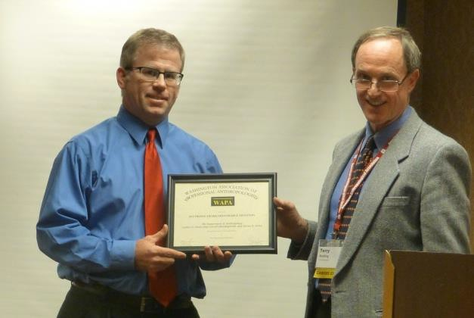
Photo: Department of Anthropology Chair Steve Nash accepts the Praxis Award Honorable Mention.

In 2007, the Department of Anthropology at the Denver Museum of Nature & Science launched its ground-breaking Repatriation Initiative both to address the legacies of its own collections and to contribute to the complex debates surrounding the care and return of cultural items and human remains in museums. Using anthropological understandings of cultural property, the cultural power of human remains, collaborative methodologies, and reparative justice, over the last five years the department has made momentous contributions to one of the most difficult and polarizing issues facing modern museums.

Interestingly, this was actually the only award whose team was working within “traditional” or typical anthropological contexts, in this case a museum’s archaeological collection. The team first restored the museum to federal NAGPRA compliance and mended relations with Native American stakeholders, and in the process exceeded government standards and raised institutional awareness of the importance of addressing stored human remains. The team concluded several successful repatriations of remains and also established a Native American Sciences Initiative, comprising five programs (a scholarship program, a career day, etc.). In addition, the project went beyond NAGPRA concerns to address the remains of September 11 victims and native artwork from Kenya.

Comments from one of the Praxis jurors help relate why the project was selected for an honorable mention:

“In the course of repairing relations between the DMNS and its Native American stakeholders, the Repatriation Initiative raised awareness about the affective, collective significance of human remains in public spaces, from Denver to East Africa to Ground Zero in New York. The team’s application conveyed a multi-layered anthropological sensibility, from the project's roots in longstanding disciplinary debates about who controls the past, to the activist/action orientation of its principals, to social responsibilities of museums as stewards of public memory, to the practicalities of project funding, methodology, and participatory research activities.”

The department is represented for the award by Chip Colwell-Chanthaphonh and Stephen E. Nash. Dr. Colwell-Chanthaphonh is curator of anthropology at the Denver Museum of Nature & Science. Dr. Nash is curator of archaeology and chair of the Department of Anthropology at the Denver Museum of Nature & Science.

Honorable Mention: Laurie Schwede, Rodney Terry, and the Research Team for the Center for Survey Measurement, U.S. Census Bureau have earned a 2013 Praxis Award Honorable Mention for their competition entry: 2010 Census Program of Evaluations and Experiments Evaluation: Comparative Ethnographic Studies of Enumeration Methods and Coverage across Race/Ethnic Groups in the 2010 U.S. Census
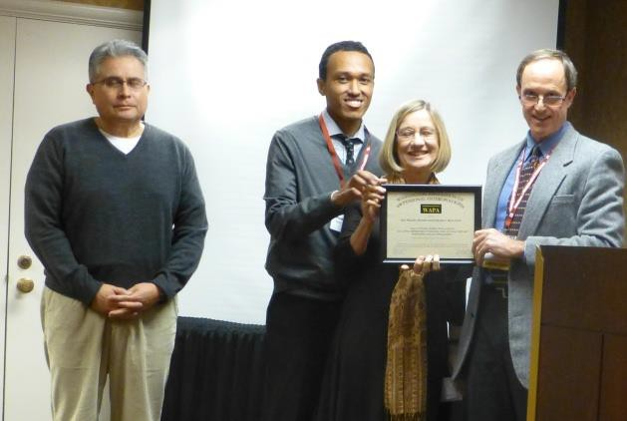

Photo: Team members Victor Garcia, Rodney Terry and Laurie Schwede accept the Praxis Award Honorable Mention on behalf of all team members.

This 2010 Census evaluation explored differences among race/ethnic groups in types and sources of coverage error and who is affected, to reduce differential undercounting, improve methods and suggest 2020 Census research. Using a controlled-comparison design, 17 ethnographers observed, audiotaped live interviews, conducted debriefings to identify and resolve coverage errors in the Census and a later survey in nine sites-American Indian, Alaska Native, Native Hawaiian, Asian, black, non-Hispanic white, Hispanic, Middle Eastern, and general sites, and wrote reports. A validation of observed households was done with final Census records to identify possible inconsistencies and coverage errors. The overall report includes recommendations.

Every decade, concerns about the under-representation of certain populations in the US Census drive discussions about the use of statistical estimates versus direct counts for demographic completeness and accuracy. This application described how anthropological methods were systematically and relevantly applied to identify factors contributing to the under-representation of non-whites in national population estimates. Within the context of a large federal bureaucracy, the application shows a meaningful contribution to the potential accuracy of the Census, with enormous potential implications in the future.
Comments from one of the Praxis jurors help relate why the project was selected for an honorable mention:
“This is multi-sited, multi-researcher, multi-method research with massive policy implications, at an almost intimidating scope and scale. When one considers that Schwede is leading an observational qualitative research project within the quantitative organizational culture of the US Census Bureau, the project becomes almost heroic.”
Drs. Schwede and Terry are on the staff of the Center for Survey Measurement, U.S. Census Bureau in Washington, DC. Additional team members and their sites include the following:

Anthropologists: Alexis Bunten (Alaska Natives), Ephrosine Daniggelis (Native Hawaiians), Rachel Donkersloot (Alaska Natives), Ted Fortier (American Indians), Victor Garcia (Hispanics), Sylvester Lahren (American Indians), Heather McMillen (Native Hawaiians), and Ruth Sando (generalized site).
Other ethnographers: Robin Albee (non-Hispanic whites), Rae Blumberg (generalized site), Angel
M. Foster (Middle Easterners), Eleanor Hubbard (non-Hispanic whites), Robin Jarrett (African Americans), Karyn Lacy (African Americans), Alison Newby (Hispanics), and Dawn Lee Tu (Asians: Chinese).
Award Jurors and Committee

WAPA would like to express deep appreciation for the work done by the 2013 award jurors to thoroughly examine the many applications received this cycle, and to thoughtfully provide comments and ratings for the award: H Russell Bernard from U Florida; Laura McNamara from Sandia Labs in New Mexico; and Stan Yoder, past WAPA president, from ICF Macro.

The Praxis Committee consists of Frances Norwood, James Stansbury, award founder Robert Wulff, and Terry Redding.

The Praxis Award for Excellence in the Practice of Anthropology was established by the Washington Association of Professional Anthropologists in 1981 and is competed on a biennial basis. Click here for nomination information.

Updated 25 November 2013

1/8/2018 Washington Association of Professional Anthropologists - 2015 Praxis Award winners

Back to list

2015 PRAXIS AWARD WINNERS
06 Dec 2015 8:18 PM | Terry Redding (Administrator)
WAPA would like to congratulate the four recipients (co-winners and two honorable mentions) of the 2015 Praxis Award.

Past WAPA President and longtime member Mari Clarke and her team received the award for their project "Improving Awareness and Technical Skills in Road Maintenance within the Third Rural Transport Project, Vietnam."
The Praxis Award also went to Stephen Weidlich and the AECOM team for their entry, "Little Saigon Design Guidelines" in San Diego, CA.

There were also two Honorable Mentions provided.

The ﬁrst is to LTG Associates for "Pastors at Risk: Toward an Improved Culture of Health for United Methodist Clergy in North Carolina." Several members of the team are WAPA members.

An Honorable Mention also went to Federico Cintrón-Moscoso, working with the Centro Para La Conservación Del Paisaje (Center for Landscape Conservation) in Puerto Rico, for the project “Public Participation in the Revision of El Yunque National Forest Management Plan."

Information on all the awardees and their projects is found on this website at http://wapadc.org/2015-Praxis-Award-Winners
WAPA would like to express deep appreciation for the tremendous amount of work done by the three 2015 Praxis Award jurors, who thoroughly examined many
applications and provided thoughtful comments and ratings:

Michael Agar established the MAA program at U Maryland, has authored several books, and runs his own consulting firm, Ethnoworks.

Dominique Desjeux, professor emeritus in the Anthropology Department at the Sarbonne in Paris, founded a French social anthropology professional network called AnthroPik, and runs an international consulting firm, Daize and Co.
Tracy Meerward Pester, a business anthropologist who worked as a contractor for General Motors for several years, has worked in recent years to modernize anthropological ethics statements to more closely align with the actual work done by practicing anthropologists.

The 2015 Praxis Committee consists of Shirley Buzzard, Jenny Masur, Stan Yoder, and Terry Redding (chair).

Add comment

1/8/2018 2017 Praxis Award Recipients



Washington Association of Professional Anthropologists

Recognizing Excellence in Practitioner Anthropology

2017 PRAXIS AWARD RECIPIENTS

WAPA is pleased to announce the ﬁve recipients of the 2017 Praxis Award. There was one ﬁrst place award, and four honorable mentions. Typically, a maximum of four awards are presented, demonstrating that 2017 was a very competitive year, reﬂecting the tremendous value of the work being done by anthropologists. The awards were presented on December 1, 2017, in Washington, DC, immediately following the business meeting of the National Association for the Practice of Anthropology.

The 2017 Praxis Award recipient is Luisa Cortesi, Yale University, for the competition entry, “Dug-well Revival: Tradition, Knowledge, and Equity in Drinking Water in North Bihar, India.”
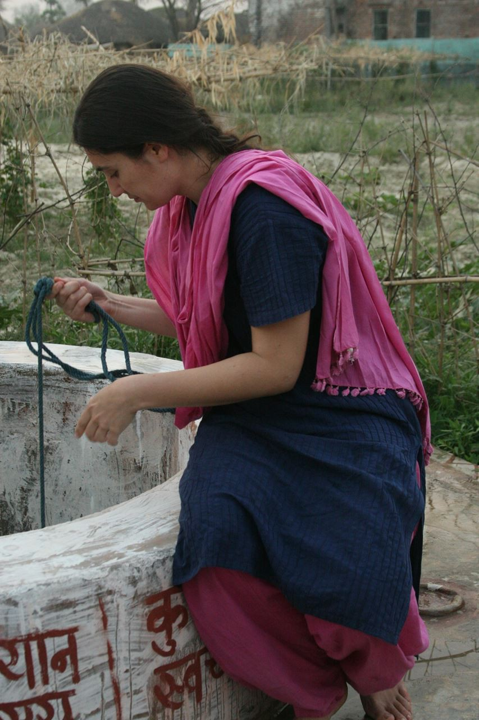
Project Client: Megh Pyne Abhiyan (a network of local rural NGOs)

The project application describes how in the ﬂooded areas of North Bihar, India, one of the country’s poorest states, development organizations working on drinking water found that bacteriologically contaminated “dug-well” water was easier to clean than “hand-pump” water, which were polluted with heavy metals. However, dug-wells are historically characterized by caste-based discrimination, and local peoples largely preferred the modern hand-pump. Ethnographic research revealed that hand-pumps, which are promoted by the state and by international organizations, are also power-laden, while a dug-well revival can work to promote self-help and community-building. Instead of merely supplying a solution, the project chose to engage people in conversations about dug-wells, and encouraged knowledge transmission on how to clean them. As a result, several families started to revive dug-wells, cleaning and restoring them at their own expense. The state later reimbursed some of the costs for these activities. By engaging people in conversations, the project achieved the independent and equitable revival of dug-wells by their users. The application also described how a single, European woman was able to get accepted into communities over the course of several years, using patience and cultural awareness and sensitivity.

1/8/2018 2017 Praxis Award Recipients
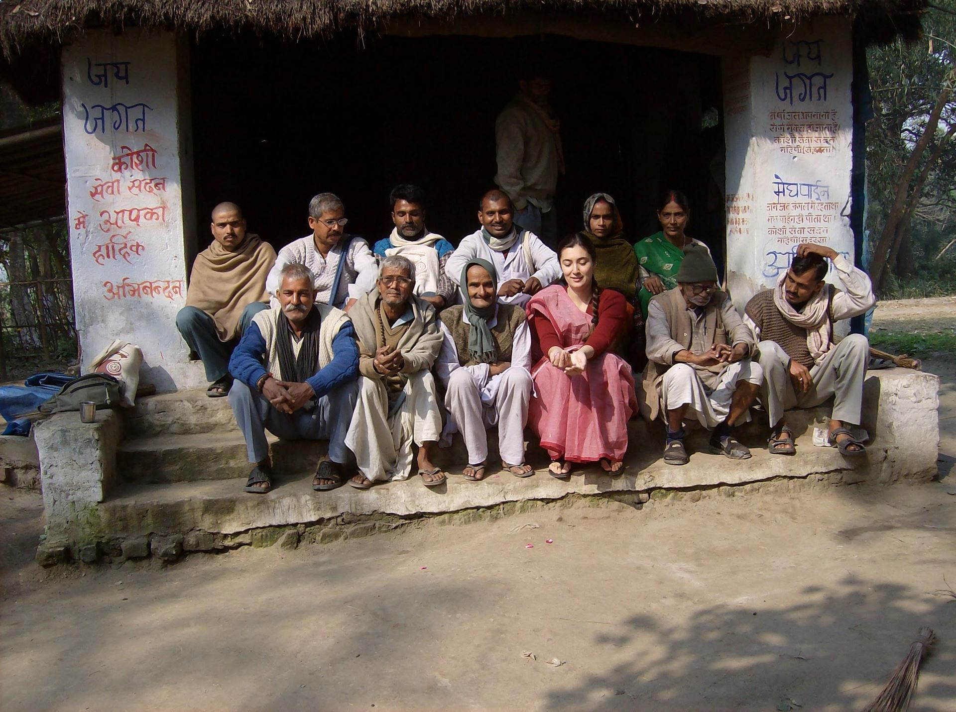

Luisa Cortesi (front row) with one of the ﬁve Megh Pyne Abhiyan (MPA) project teams who worked on the dug well project. The team members are Puspa (back row, second from right), Reeta (back row, far right), Aditya (back row, second from left), and the late Pawan (back row, third from right). The front row includes three volunteers of KSS, the Gandhian organization that partnered with MPA on this project. Ram Poddar Babaji (front row, second from right), 90 years old, was particularly supportive, and roamed across rivers and at times the country with the awardee.

Praxis Juror comments:

“This intervention, in which Cortesi played a signiﬁcant role as both aid worker and engaged anthropologist, had multiple beneﬁts: providing local communities with a new (old) way to access water that's demonstrably safer for human health; the revival of a local practice beyond the immediate communities to adjacent regions; and an empowering action that challenges Bihar's entrenched caste system. It's hard to overstate the public health beneﬁts of this intervention for the communities involved. I hope that Cortesi and her colleagues document this work to enable other aid workers/aid groups to adopt the same techniques and perspectives in promoting access to clean, safe water.”

Luisa Cortesi is a joint Ph.D. candidate in Environmental Anthropology, Yale University (2018 expected), and the School of Forestry & Environmental Studies. She has a cumulative total of seven years of applied research in rural India, of which over ﬁve years are in North Bihar. She was assisted in her efforts by Eklavya Prasad, a social worker with 20 years of social development experience in India, of which 15 are on water issues.

Honorable Mention: Cathleen Crain, Nathaniel Tashima, Reiko Ishihara-Brito, and Erick Lee Cummings, of LTG Associates, Inc., for the project, “A Video Ethnographic Study: Raising Healthy Children in Poverty and Examples of Excellence in Addressing Childhood Wellness.”
Project Client: California State Department of Health Care Services

The LTG Associates team of anthropologists and a videographer developed two, one-hour long video ethnographies for the California Department of Health Care Service, which were focused on healthy families and communities. They were designed to bring the faces and voices of participants and their worlds into direct relationship with policymakers, program developers, and legislative staff and legislators

1/8/2018 2017 Praxis Award Recipients
for the State of California. These videos have been used for brieﬁngs, trainings, and policy and program development. The videos were co-created with community leaders engaged in innovative community health projects and parents in poor conditions working to raise healthy children.
The award application noted that the project could have been carried out by other professionals, but the anthropological difference began with the reframing of the community participant-focused research questions to center on families and their lived experience and context. It continued through the identiﬁcation and recruitment of participants through the use of social networks. The video interviews and the creation of the presentations depicted the lives of individuals that were then validated by the participants, closing the loop from interview to data to analysis to ﬁnal video production.

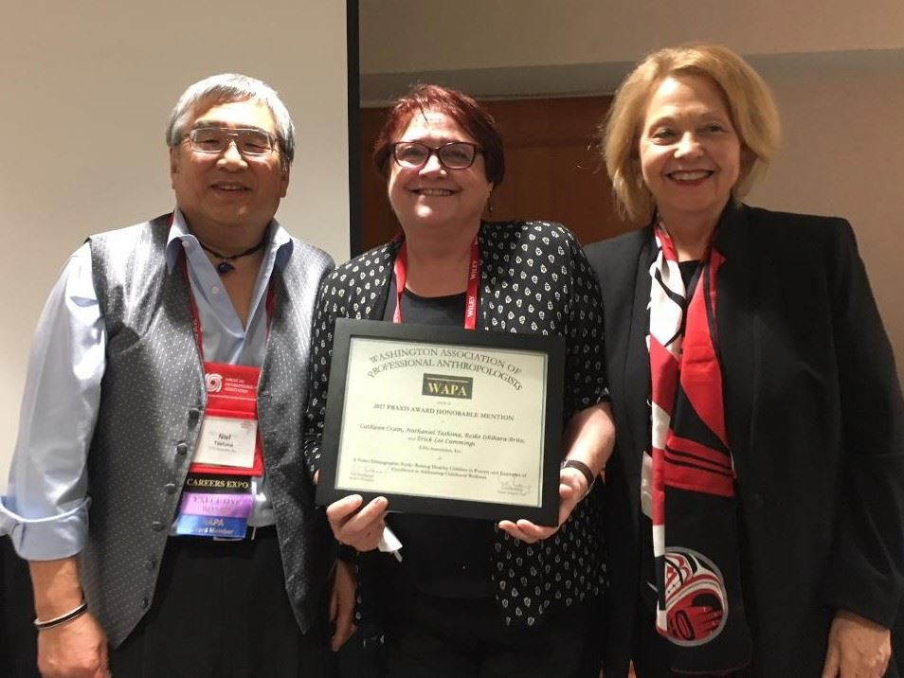

LTG Associates principals Niel Tashima (left) and Cathleen Crain (right) accept the honorable mention from committee member Suzanne Heurtin-Roberts

Praxis Juror Comments:

"The narrative explains how the team argued for an empathetic, ethnographic approach to elicit the health experiences of families. Importantly, the ethnographers present themselves as learners rather than experts. The videos provide evidence of the team's effectiveness in crafting the kind of empathetic, empowering message they sought to provide policymakers. It's a nice example of ethnographic ﬁlmmaking… I love the ethnographic sensibility of this project."

Cathleen E. Crain is one of the two founding and Managing Partners of LTG Associates. She is a senior social scientist with over 40 years of experience in health and human services provision, program development, policy analysis, evaluation, training, and technical assistance for international, federal, state, and local governmental and non-governmental organizations.
Nathaniel (Niel) Tashima is one of the two founding and Managing Partners of LTG Associates, and has been engaged for more than 40 years in projects that have focused on creating knowledge about families and communities and opportunities for their voices to be engaged in shaping programs and developing polices that effect their lives.
Reiko Ishihara Brito is a Research Associate at LTG Associates. Her work experience ranges from serving as a union to working with indigenous communities in Central America.
Erick Lee Cummings has more than eight years of professional experience producing, shooting, editing and directing video. He is currently a freelance Digital Filmmaker and Video Editor for various outlets.

Honorable Mention: Adam B. Seligman, Rahel R. Wasserfall, and David W. Montgomery, CEDAR (Communities Engaging with Difference and Religion) Program, for the ongoing project, “Learning to Live with Difference: Taking Anthropology Out of the Classroom and Into the World.”

1/8/2018 2017 Praxis Award Recipients
Clients: Clients at the time of the award included: Plovdiv University (Bulgaria); Uganda Martyrs University (Uganda); Southern Africa Interfaith and Peace Academy (Zimbabwe); KICORA (Tanzania and Berundi); Institute of Resource Governance and Social Change (Indonesia); Yamaguchi Prefectural University ( Japan); and Hardin-Simmons University (USA).
CEDAR is a global educational network that runs fortnightly programs enabling members of disparate communities to recognize and accept their differences as they work toward a civil society. The group combines a unique, anthropologically informed pedagogy of cognitive learning (lectures), experiential learning (site visits), and affective learning (group work) to build communities that respect difference rather than emphasize sameness. This structure, together with an international and diverse body of fellows, provides a powerful experience that forces participants to challenge their taken-for-granted assumptions about the self, the other, and the terms of interaction, therein creating a new space for living together differently. Unlike other interfaith and inter-communal programs, which play down fundamental dissimilarities between people in favor of emphasizing what they have in common, CEDAR places difference squarely at the top of the agenda. In fact, the key to CEDAR’s approach is the requirement that participants confront one another’s differences—and then learn how to live with them. In two intensive weeks, participants experience unfamiliar religious customs, grapple with beliefs that contradict their own, reexamine lifelong assumptions, and ﬁgure out how to share time and space.

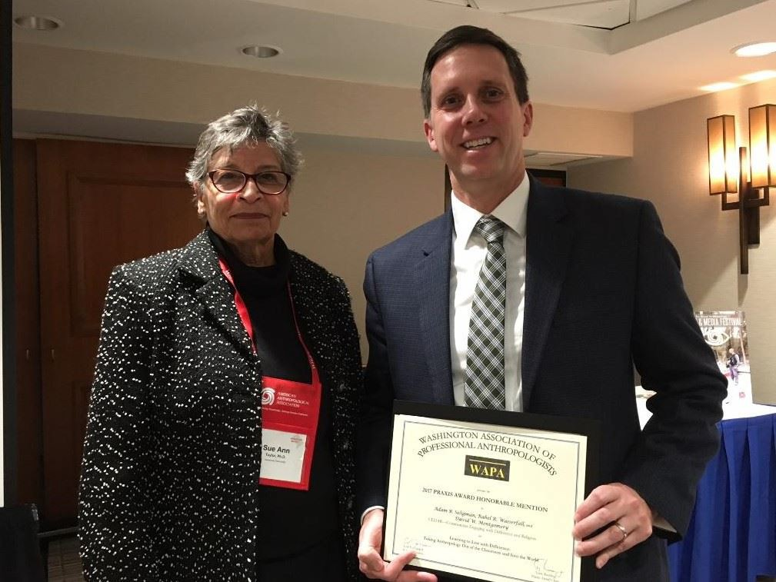

CEDAR member David Montgomery accepts the honorable mention from committee member Sue Taylor Praxis Juror Comments:
“For a program that has been around as long as CEDAR, and that has engaged such a wide range of challenges in so many different locations, it is not easy to measure in terms of linear/uniform results. However, longitudinal survey data indicate that participants carried the CEDAR experience forward in their careers. CEDAR team members have published extensively on their theory, method, and experience. That is potentially a huge impact multiplier, insofar as they are producing resources to help other conﬂict-reduction interventions to understand and implement the CEDAR approach. Helping individuals, groups, and communities recognize and accept difference as an inescapable, inevitable, and, most importantly, acceptable part of our social experience has to be one of the most important projects anyone can pursue these days. I really admire this team's dedication to what must sometimes feel like an overwhelming problem.”

Rahel R. Wasserfall is CEDAR’s lead anthropologist and Director of Evaluation and Training. She is also a resident scholar at Brandeis University, focusing on evaluation of educational activities in cross-cultural settings.
David W. Montgomery, CEDAR’s Director of Program Development, is a Policy Fellow with the American Association for the Advancement of Science and a Research Associate in the Department of Anthropology at the University of Pittsburgh, where he taught for six years as a Visiting Assistant Professor, and Associate in the Central Asia Program at George Washington University.
Adam B. Seligman, CEDAR’s Founding Director, is a social theorist in the Department of Religion at Boston University, where he teaches courses cross-listed in the Department of Anthropology.

1/8/2018 2017 Praxis Award Recipients
Honorable Mention: Thurka Sangaramoorthy, University of Maryland, and the Project Team, for the “Marcellus Shale Public Health Study.”
Project Client: State of Maryland

In 2011, then-governor of Maryland Martin O’Malley established the Marcellus Shale Safe Drilling Initiative to assist state policymakers and regulators in determining whether and how unconventional natural gas development and production (i.e., fracking) from the Marcellus Shale in Maryland could be accomplished without unacceptable risks to the environment and the populace. This initiative required research assessing the impacts of drilling on the environment, the economy, and health. A state-wide public health impact assessment of fracking, the ﬁrst of its kind, was commissioned and conducted by a team of interdisciplinary researchers with input from residents and a variety of other stakeholders. The project represents several innovations, such as the utilization of a health impact assessment, which uses participatory research to foster a relatively high degree of control over research by community members and stakeholders and is meant to equalize power within the research process; and the development of a hazard ranking methodology to assess potential public health impacts, which is a valuable tool that allowed the team to systematically evaluate each hazard related to fracking and provide recommendations to minimize the hazards. Both can be easily adapted by other communities facing similar situations as well as in other settings that entail making decisions with limited information. Although community residents welcomed the potential economic growth brought about by fracking, anthropological analyses led to ﬁndings that indicated fracking also generated rapid transformations in meanings of place and social identity, increasing people’s anxieties of environmental and health impacts.

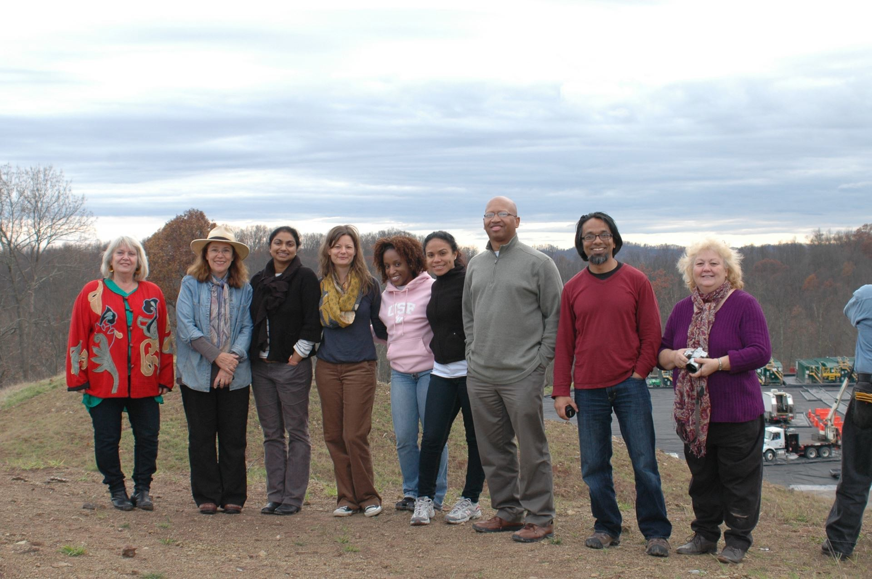

Thurka Sangaramoorthy (third from left) with research team and community members in West Virginia.

Praxis Juror Comments:

"I think this project stands as an outstanding example of how anthropology can help people understand key environmental issues, obtain pertinent data, and as a result, help shape policy. The approach used can be used elsewhere, and indeed, this project can be used as a case study for training."

Thurka Sangaramoorthy is an Assistant Professor in the Department of Anthropology at the University of Maryland. She was a postdoctoral associate for three years at the U.S. Centers for Disease Control and Prevention (CDC), where she conducted studies using rapid ethnographic assessments and health impact assessments in order to implement practical, timely, and sustainable interventions, and she coordinated trainings in both of these methods for public health professionals.

1/8/2018 2017 Praxis Award Recipients

Honorable Mention: Olive M. Minor, IRC, for the effort, “Socio-cultural Barriers and Enablers in the Ebola Response.” Project Client: Oxfam GB
This project aimed to support Oxfam’s Public Health Promotion (PHP) strategies by integrating anthropological approaches into the humanitarian response to the 2014 West African Ebola epidemic. At the time of the project, most people in Oxfam’s areas of operation in Liberia and Sierra Leone had moderate to high awareness of Ebola prevention and treatment information. However, infections continued to ﬂare across the region. In early November 2014, the applicant supported Oxfam’s PHP strategies in Liberia and Sierra Leone by identifying barriers to compliance with Ebola prevention and treatment advice, and by contributing to the development of local-level response activities. She developed rapid qualitative assessments to identify points of friction between Ebola-affected communities and response activities, and offered recommendations for improvements in Oxfam’s strategies. Oxfam PHP teams used these assessments to adjust operations on a daily basis, incorporated recommendations into longer-term strategies, and captured lessons learned for future epidemic responses. Ultimately, this role produced a multi-level engagement with Oxfam’s Ebola response strategy: (1) contributing input to adjust tactics in real time, (2) incorporating recommendations into short-term response and long-term recovery strategies, (3) capturing lessons learned for future epidemic response, and (4) integrating reﬂexivity into humanitarian response.

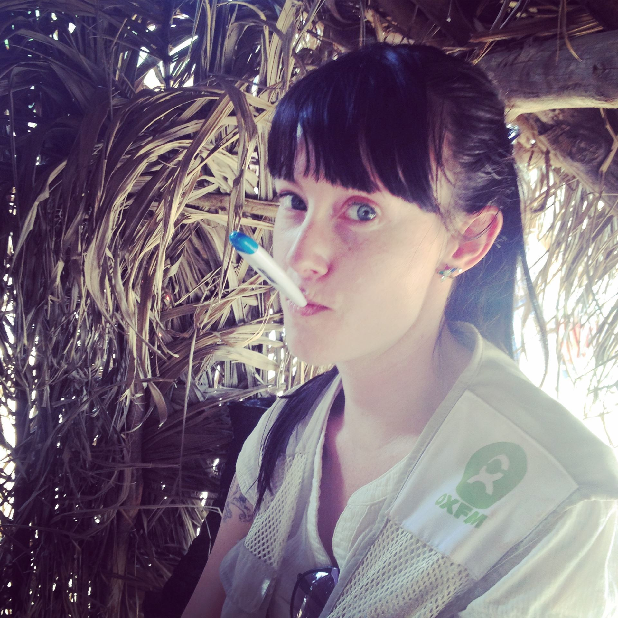

Olive Minor at a temperature checkpoint in Sierra Leone during the Ebola outbreak

Praxis Juror Comments:

“The applicant’s observations seem to have inﬂuenced how the Oxfam PHP teams engaged local communities (for example, by recognizing the mediating role of informal healers and by engaging local development groups in reducing distrust of medical oﬃcials). She also makes the dead-on observation about ‘culture scapegoating’ in international aid organizations: that rural African communities are placed at a disadvantage because ‘local culture’ inhibits the kind of rational response that Western aid groups are trained to deploy in emergencies.
As she points out, organizations would beneﬁt from a dose of anthropological reﬂexivity in assessing how their own response activities contribute to a breakdown in trust between caregivers and local populations.”

Olive Melissa Minor is a Mellon/ACLS Public Fellow and a research & evaluation oﬃcer with the International Rescue Committee. Her previous work includes identifying barriers to HIV prevention and treatment for transgender Ugandans, and applying anthropology to design health programs for pregnant teens in Cameroon.

WAPA would like to thank the 2017 Praxis Award jurors, who spent many hours diligently reviewing and commenting on the award applications. This cycle's jurors included Charles Cheney (NIH, retired); Mari Clarke (World Bank); Laura McNamara (Sandia National

1/8/2018 2017 Praxis Award Recipients
Laboratories); and Riall Nolan (Purdue University).

The 2017 Praxis Award Committee included Suzanne Heurtin-Roberts, Adam Koons, Jim Stansbury, Sue Taylor, and Terry Redding (chair).

(c) 2017 Washington Association of Professional Anthropologists Contact WAPADC with questions or comments.

